Who Gives A Dam?
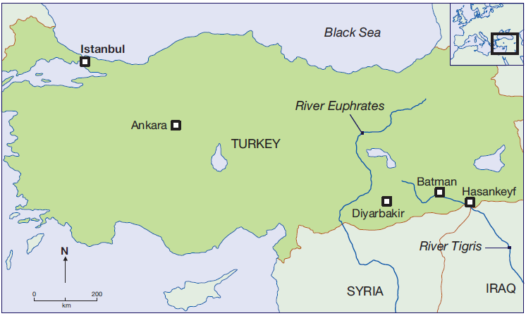
What is a dam? A dam is a barrier or structure across a stream, river or waterway to confine and control the flow of water.

As the world’s population and economy grows, demands for water increases. More dams are built to store water and supply power

Case Study: Ilisu – A Disputed Dam
Under proposals to build an energy-generating dam in south-eastern Turkey, the ancient town of Hasankeyf on the Tigris River would be flooded. The town dates back to 10,000 years. Evidence of Roman, Ottoman and other cultures are still buried in the area. Caves carved out of Hasankeyf’s limestone cliffs one provided shelter and storage space for locals.

Hundreds, if not thousands, of historic sites in the areas have barely surveyed. These would be submerged by the large reservoir

Location:
River Tigris in south-east Anatolia, 65km upstream of Syria and Iraqi boarder

Dimension:
A rockfill dam 1820m long and 125m high will create a reservoir with the volume of 10.4 billion cubic meters and a surface area of 313km²

Main Benefits:
◊ Hydroelectric power
◊ Irrigation for local agriculture
◊ Boost for regional economy and development
◊ The new resettlement plans include funding to
‘rescue’ some parts of the town of Hasankeyf
by moving them
elsewhere

Criticisms:
◊ 52 villages and 15 small towns will be
flooded, including the city of Hanankeyf
◊ The homes and livelihoods of 15,000
-20,000 people will be affected
◊ Threatens hundreds of ancient sites,
including Kurdish and other
archaeological heritage
◊ The dam will have a life of fifty to
seventy years, but a beautiful site will
be permanently destroyed
◊ The reservoir may encourage
waterborne diseases like malaria to the
region
◊ It will create Kurdish refugees-fuelling
conflict between the Turkish state and
the guerrilla of the PKK
◊ Will reduce the quantity and quality of
water reaching Iraq and Syria, increasing
tensions
◊ Resettlements plans will not help the
people who lose their homes and
livelihood, or save the hundreds of
archaeological sites from being drowned
◊ The unity of the area would be
destroyed by demolishing the town in
the valley and moving some relics to
another place

