Name _______________________________________________
Weather and Climate Test
1. What do the following terms mean? (4 marks)
a. Temperature means ______________________________________________________
b. Precipitation means ______________________________________________________
c. Wind speed means _______________________________________________________
d. Wind direction means _____________________________________________________

2. What are the three different kinds of rainfall? (3 marks)
______________________________Rainfall
______________________________Rainfall
______________________________Rainfall

3. What is weather? What is climate? What is the difference between weather and climate? (3 marks)
Weather is _______________________________________________________________
Climate is ________________________________________________________________
The difference is __________________________________________________________
________________________________________________________________________

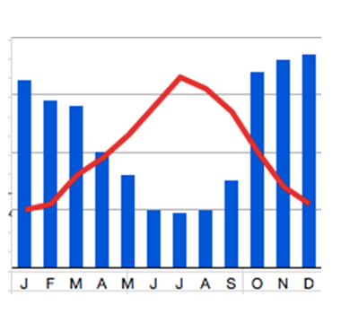
4. What two types of weather does a climate graph show? (2 marks)
1. ______________________________
2. _____________________________

5. What two things are missing from the climate graph to the left? (2 marks)
1. _________________________________________________
2. ________________________________________________
6. What are the two main causes of weather? (2 marks)
1. ________________________________________________
2. ________________________________________________
7. You have studied six factors which influence climate. Using a diagram describe and explain two of these factors. (6 marks)
Factor:___________________________________________________________________
____________________________________________________________________________________________________________________________________________________________________________________

Factor:___________________________________________________________________
____________________________________________________________________________________________________________________________________________________________________________________

8. The earth can be divided into six regions with very different climates. Give 6 different examples of global climate zones. (6 marks)
1. ________________________________________________
2. ________________________________________________
3. _______________________________________________
4. ________________________________________________
5. _______________________________________________
6. ________________________________________________
9. Label the following instruments; explain what each instrument is used for (12 marks)
 | Name of equipment | What is it used for?

Mark: /40
Areas for improvement:

Comment:

Name _______________________________________________
Weather and Climate Test ANSWERS
1. What do the following terms mean? (4 marks)
a. Temperature means how hot or cold something is, measured in degrees centigrade.
b. Precipitation means water falling from the sky; it could fall as rain, hail, sleet or snow.
c. Wind speed means how fast the wind is blowing.
d. Wind direction means he direction the wind blows from.

2. What are the three different kinds of rainfall? (3 marks)
Convectional, relief, frontal

3. What is weather? What is climate? What is the difference between weather and climate? (3 marks)
Weather is the state of the atmosphere at any given time.
Climate is the average weather in a place; what the weather is usually like there.
The difference is climate shows an average, not the actual weather conditions of any given time.

4. What two types of weather does a climate graph show? (2 marks)
Temperature, precipitation

5. What two things are missing from the climate graph to the left? (2 marks)
Title, labels
6. What are the two main causes of weather? (2 marks)
Sun, Water vapour
7. You have studied six factors which influence climate. Using a diagram describe and explain two of these factors. (6 marks)
1. Latitude: how far a place is from the equator.
2. The earth’s tilt: seasons.
3. Distance from the coast: sea is cooler than land in summer and warmer in winter.
4. Prevailing wind direction: from south west bringing water vapour= rain.
5. Ocean currents: Warm ocean current called North Atlantic Drift warms the west coast of the UK by warming the wind.
6. Height above sea level/altitude: The higher you are the cooler it is. Falls 1 degree for every 100m.
8. The earth can be divided into six regions with very different climates. Give 6 different examples of global climate zones. (6 marks)
Hot tropical rainy climates, very dry climates, cold polar climates, warm summers, mild winters, cool climates, mountain climates.
9. Label the following instruments; explain what each instrument is used for (12 marks)
 | Name of equipment | What is it used for?
 | Thermometer | Temperature
 | Barometer | Measuring air pressure
 | Rain gauge | Rain
 | Visibility meter | How far you can see
 | Wind vane | Wind direction
 | Anemometer | Measuring wind speed

Mark: /40
Areas for improvement:

Comment:

