**1.** Study the figure belowwhich shows the growth of traffic in Cambridge, a large city in the UK.

Name: Date: Marks /29 Grade:

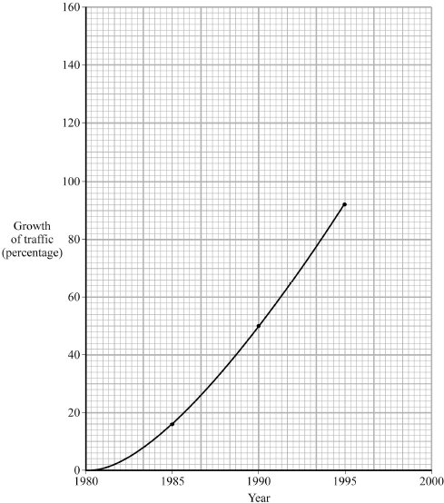

From *People, Places and Themes* by BILHAM-BOULT, BLADES, HANCOCK, RIDOUT.  
Reprinted by permission of Pearson Education.

(i) Complete the graph by plotting the 2000 figure of 145%.

(1)

(ii) What was the percentage growth between 1990 and 2000?

.............................%

(1)

(iii) How long did it take for the amount of traffic in Cambridge to increase by 100%?

..............................................

(1)

(iv) Describe **one** way in which increased traffic can affect settlements such as Cambridge.

.....................................................................................................................................

.....................................................................................................................................

.....................................................................................................................................

.....................................................................................................................................

(2)

(v) How does a traffic solution you have studied help to reduce the problem of traffic in settlements?

.....................................................................................................................................

.....................................................................................................................................

.....................................................................................................................................

.....................................................................................................................................

.....................................................................................................................................

.....................................................................................................................................

.....................................................................................................................................

.....................................................................................................................................

(4)

(Total 9 marks)

**2.** The Central Business Districts (CBDs) of some cities in MEDCs are facing problems.

(i) Describe the problems affecting the CBDs of some cities in MEDCs.

.....................................................................................................................................

.....................................................................................................................................

.....................................................................................................................................

.....................................................................................................................................

.....................................................................................................................................

.....................................................................................................................................

.....................................................................................................................................

.....................................................................................................................................

(4)

(ii) Using a **named** urban area, describe what has been done to improve the CBD.

Name of urban area ....................................................................................................

.....................................................................................................................................

.....................................................................................................................................

.....................................................................................................................................

.....................................................................................................................................

.....................................................................................................................................

.....................................................................................................................................

.....................................................................................................................................

.....................................................................................................................................

(4)

(Total 8 marks)

**3.** Study the figure below, which shows the population change of an inner city area in an MEDC between 1901 and 2001.



Suggest reasons for the population changes shown on the figure above.

...............................................................................................................................................

...............................................................................................................................................

...............................................................................................................................................

...............................................................................................................................................

...............................................................................................................................................

...............................................................................................................................................

...............................................................................................................................................

...............................................................................................................................................

(Total 4 marks)

**4.** (i) Describe **two** ways in which inner city areas have changed in recent years.

1 ..................................................................................................................................

.....................................................................................................................................

2 ..................................................................................................................................

.....................................................................................................................................

(2)

(ii) Explain why **one** of these changes has occurred.

.....................................................................................................................................

.....................................................................................................................................

.....................................................................................................................................

.....................................................................................................................................

.....................................................................................................................................

.....................................................................................................................................

(2)

(Total 4 marks)

**5.** Study **Figures 1** and **2**. **Figure 1** is a map showing the areas of Inner and Outer London. **Figure 2** gives the population of Inner and Outer London between 1801 and 2001.

**Figure 1**



|  |  |  |
| --- | --- | --- |
| **Year** | **Inner London (Millions)** | **Outer London (Millions)**  **Figure 2** |
| 1801 | 1.0 | 0.1 |
| 1841 | 2.0 | 0.2 |
| 1881 | 3.9 | 0.8 |
| 1921 | 4.4 | 3.0 |
| 1961 | 3.3 | 4.8 |
| 2001 | 2.8 | 4.1 |

(i) Give **two** ways that the population of London changed between 1801 and 2001.

1 ..................................................................................................................................

.....................................................................................................................................

2 ..................................................................................................................................

.....................................................................................................................................

(2)

(ii) Circle the **two** urban zones in the following list which are part of Outer London.

**CBD** **Suburbs** **Rural–Urban fringe** **Inner city**

(2)

(Total 4 marks)