**1.** (i) What is the meaning of the term ‘urbanisation’?

.....................................................................................................................................

.....................................................................................................................................

.....................................................................................................................................

.....................................................................................................................................

(2)

(ii) Study the following table.

|  |  |  |  |
| --- | --- | --- | --- |
| **Country A** | | **Country B** | |
| **1950** | **2000** | **1950** | **2000** |
| **Rural population (%)** | 75 | 75 | 75 | 50 |
| **Urban population (%)** | 25 | 25 | 25 | 50 |

Which country became more urbanised between 1950 and 2000?

.....................................................................................................................................

(1)

(Total 3 marks)

**2.** The CBD is a zone in a city.

(i) What do the letters CBD stand for?

.....................................................................................................................................

(1)

(ii) Tick the correct box to show whether each of the following statements about the CBD is **True** or **False**.

**True False**

There are a large number of houses in the CBD.  

There are department stores and office blocks in the CBD.  

Many factories are found in the CBD.  

The CBD is the area with the greatest number of pedestrians.  

(4)

(iii) Study the figure below, which shows some problems in the CBDs of cities in MEDCs.

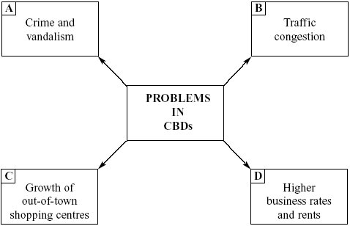

Choose **two** of the above and explain the effects that they have had on CBDs.

Letter ...................

.....................................................................................................................................

.....................................................................................................................................

.....................................................................................................................................

.....................................................................................................................................

Letter ...................

.....................................................................................................................................

.....................................................................................................................................

.....................................................................................................................................

.....................................................................................................................................

(4)

(iv) Using a named urban area, describe what has been done to improve the CBD.

Name of urban area .....................................................................................................

.....................................................................................................................................

.....................................................................................................................................

.....................................................................................................................................

.....................................................................................................................................

.....................................................................................................................................

.....................................................................................................................................

.....................................................................................................................................

.....................................................................................................................................

(4)

(Total 13 marks)

**3.** Study the figure belowwhich shows models of an unsustainable and a sustainable city.

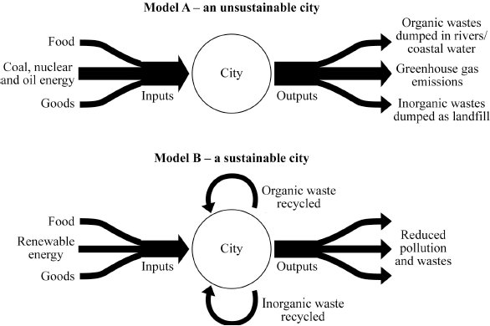

S WARN, *Student Unit Guide AS Geography Edexcel B, Unit 2*, Philip Allan Updates, 2001.

(i) Use the figure aboveto show why a sustainable city will be less damaging to the local environment and less damaging to the global environment.

Less damaging to the local environment ....................................................................

.....................................................................................................................................

.....................................................................................................................................

Less damaging to the global environment ..................................................................

.....................................................................................................................................

.....................................................................................................................................

(2)

(ii) With the help of the figure above, explain why a named settlement you have studied can be considered sustainable.

.....................................................................................................................................

.....................................................................................................................................

.....................................................................................................................................

.....................................................................................................................................

.....................................................................................................................................

.....................................................................................................................................

.....................................................................................................................................

.....................................................................................................................................

(4)

(Total 6 marks)

Name: Marks: /22 Grade:

Targets for improvement:

* Check the command word and answer appropriately.
* Check the number of marks and answer in enough detail.
* Make clear reference to maps, figures, data provided.
* Learn casestudies.
* Link casestudy detail back to the question.
* Improve understanding and use of key vocabulary.