The Colosseum

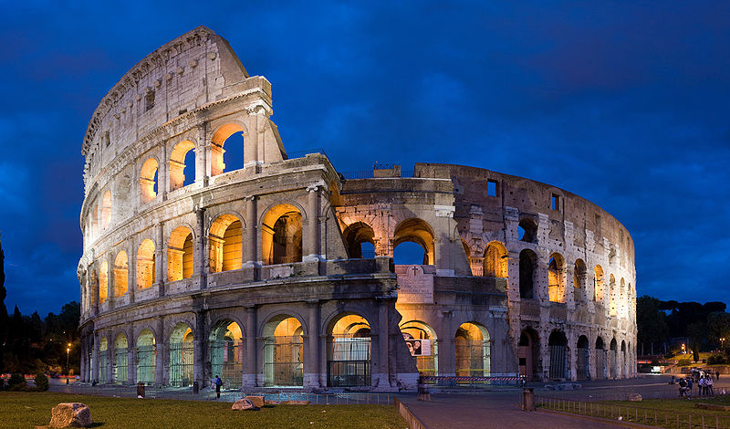

**Location:** Rome, Italy

**Built By:** The Romans. Completed in 80AD, around 1932 years ago!

**Importance:** Considered to be one of the greatest pieces of Roman Architecture.

**Tourism:** Rome is a massive tourist destination and many of these visit the Colosseum.

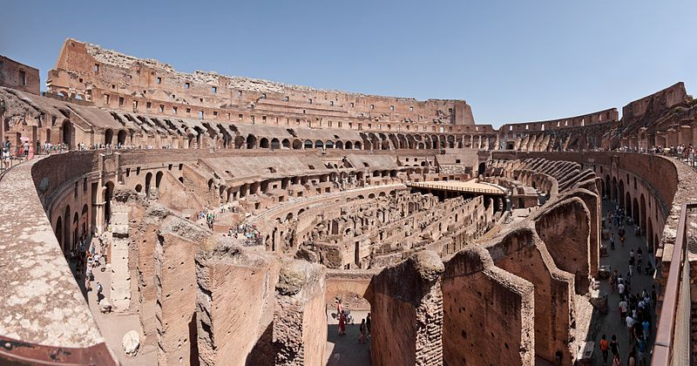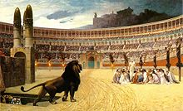

What is there to see?

Thousands of visitors every year pay to go inside the arena. It is amazing that a structure so old and with so much history is still standing.

25 Million Euros has been given to the project to help restore the building.

What was it for?

The arena originally held 50,000 people who would go to watch shows and sporting events where gladiators would compete.

There are passageways underneath the area where they used to walk lions and other animals around.

Rome: Tourism

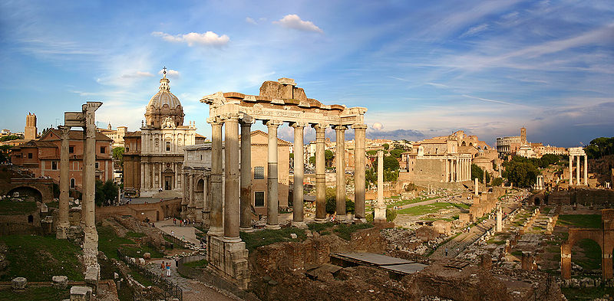

Rome is one of the most historic cities in the world and as a result gets visited by a huge number of people.

It is the third most visited city in Europe after Paris and London.

[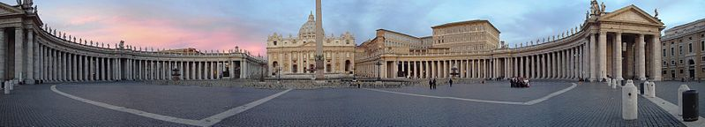](http://upload.wikimedia.org/wikipedia/commons/1/15/Vatikan_Kolonaden_Petersdom.jpg)

The Vatican

The Vatican is the home of the Catholic church and the Pope. This is an extremely important site and receives a huge amount of visitors.

Impacts

What could be the impacts of tourism in Rome?

How do you think people should respect the city and its many historic landmarks?