Taj Mahal

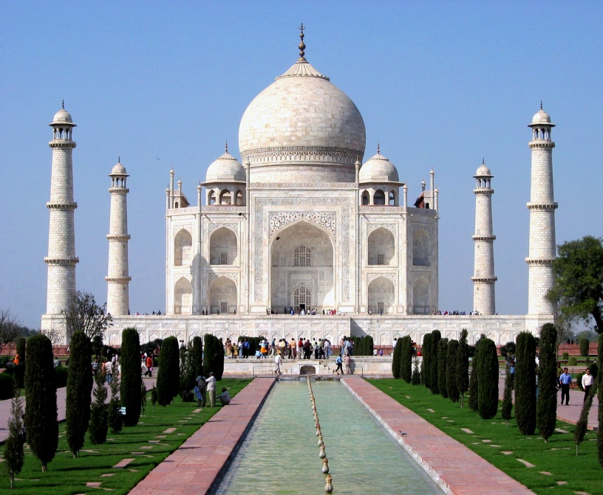

**Location:** Agra, India

**Built By:** Emperor Shah Jahan started building the Taj Mahal in 1631.

**Importance:** It is considered to be an outstanding example of Indian architecture.

**Tourism:** The Taj Mahal is a popular tourist attraction with thousands coming to see the symmetry of the structure.

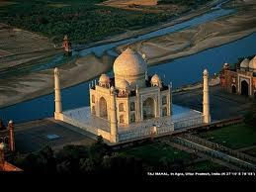

What was it for?

The Taj Mahal was built by Emperor Shah Jahan in memory of his wife, Mumtaz Mahal, who died in child birth.   
  
It took nearly twenty years to complete and required more than twenty thousand workers.

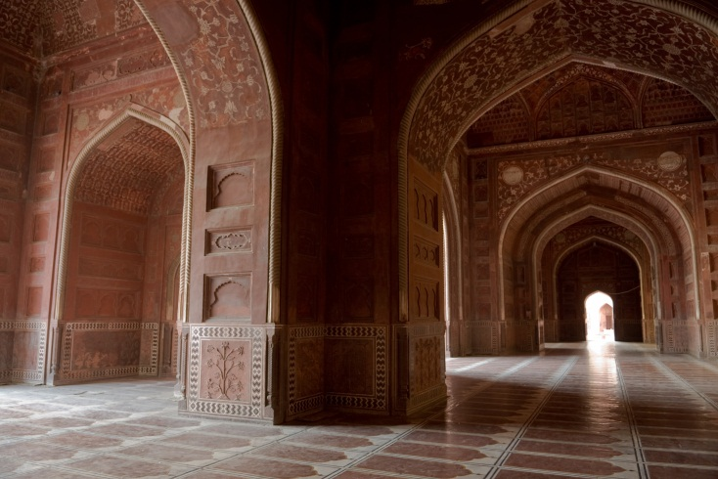

What is there to see?

The Taj Mahal appears to gradually alter its color in the changing light of the day. Some people choose to wake up early to see the building at sunrise. You can also get a great view of the building from across the river bank.  
  
Once inside you can admire great Indian architecture ranging from huge arches to marble floors.

Agra: Tourism

[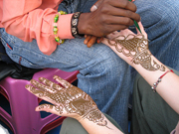](http://www.flickr.com/photos/mckaysavage/2086619002/)[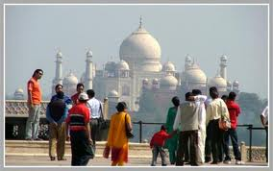](http://www.google.co.uk/imgres?q=agra+tourism&um=1&hl=en&safe=active&sa=N&biw=704&bih=775&tbm=isch&tbnid=KLxaLwie2ZiilM:&imgrefurl=http://www.touristdestinationindia.com/tour-packages/golden-triangle-tour.html&docid=vQ3IX1VOrO2N8M&imgurl=http://www.touristdestinationindia.com/tour-packages/gifs/agra-tourism.jpg&w=380&h=238&ei=R5eeT_XJDYew8gOMsf37Dg&zoom=1&iact=hc&vpx=208&vpy=233&dur=414&hovh=178&hovw=284&tx=97&ty=112&sig=118202481617076278241&page=6&tbnh=135&tbnw=210&start=77&ndsp=16&ved=1t:429,r:7,s:77,i:270)

**Taj Mahal Festival**The week long Taj Mahotsav takes place in Agra, right near the Taj Mahal, from February 18-27 each year. The focus of this festival is on arts, crafts, Indian culture, and recreating the Mughal era. It gets underway with a spectacular procession that includes elephants, camels, and drummers. Elephant and camel rides are on offer, and there are also games for the kids, and a food festival.

A beautiful building, amazing that it has been standing there for hundreds of years. Make sure you visit early as it can get very crowded. There will also be a lot of people trying to offer you tours!

The city of Agra is famous for its exceptional monuments and buildings. It houses many tombs which are dedicated to famous leaders of India.   
  
 Those interested in the history of India will have an interest in Agra.