**1.** Study the figure belowwhich shows the position of squatter settlements in the city of Nairobi in Kenya, a poor country in Africa.

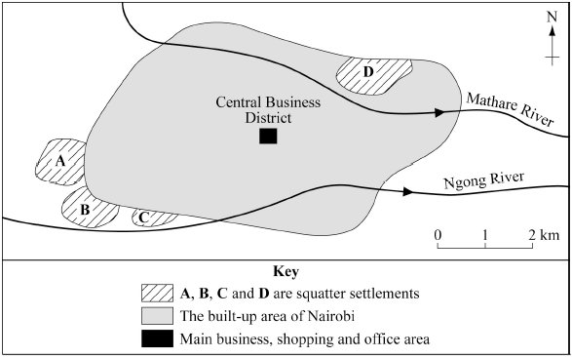

(i) Use the figure aboveto describe the location of the squatter settlements in Nairobi.

.....................................................................................................................................

.....................................................................................................................................

.....................................................................................................................................

.....................................................................................................................................

(2)

(ii) Use a named example to describe how local people living in squatter settlements have tried to improve their own lives.

.....................................................................................................................................

.....................................................................................................................................

.....................................................................................................................................

.....................................................................................................................................

.....................................................................................................................................

.....................................................................................................................................

.....................................................................................................................................

.....................................................................................................................................

.....................................................................................................................................

.....................................................................................................................................

.....................................................................................................................................

.....................................................................................................................................

.....................................................................................................................................

.................................................................................................................................... ………… (8)

(Total 10 marks)

**2.** Bangkok is the capital of Thailand, an LEDC in South East Asia.

Study the sketch map of Bangkok below.

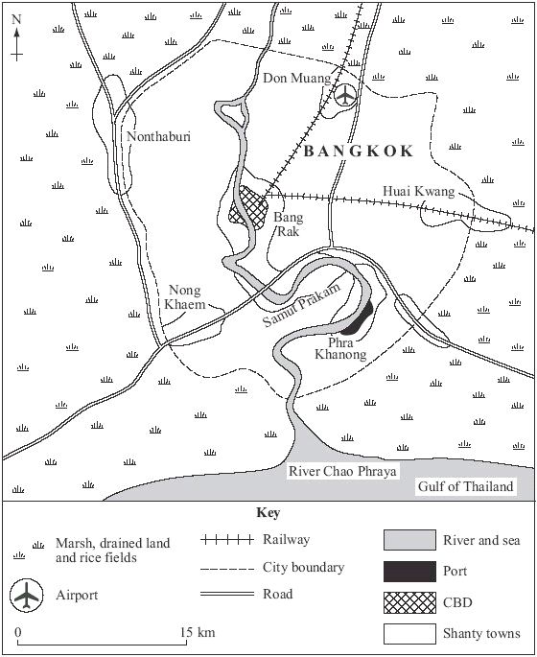

(i) Suggest reasons for the distribution of the shanty towns in Bangkok.

.....................................................................................................................................

.....................................................................................................................................

.....................................................................................................................................

.....................................................................................................................................

.....................................................................................................................................

.....................................................................................................................................

.....................................................................................................................................

.....................................................................................................................................

(4)

(ii) With the help of **one or more** examples, explain how the lives of people living in some shanty towns have been improved.

.....................................................................................................................................

.....................................................................................................................................

.....................................................................................................................................

.....................................................................................................................................

.....................................................................................................................................

.....................................................................................................................................

.....................................................................................................................................

.....................................................................................................................................

.....................................................................................................................................

.....................................................................................................................................

.....................................................................................................................................

.....................................................................................................................................

.....................................................................................................................................

.....................................................................................................................................

.....................................................................................................................................

.....................................................................................................................................

.....................................................................................................................................

.....................................................................................................................................

(9)

(Total 13 marks)

**3.** Study the figure below, which shows why the city of Kolkata (Calcutta) has grown as the result of migration and other factors.



(i) Using the figure above, give **two physical** and **two human** factors that caused a growth in Kolkata’s population.

Physical factors

1 ..................................................................................................................................

.....................................................................................................................................

2 ..................................................................................................................................

.....................................................................................................................................

Human factors

1 ..................................................................................................................................

.....................................................................................................................................

2 ..................................................................................................................................

.....................................................................................................................................

(4)

(ii) Describe the effects of rapid growth on LEDC cities, such as Kolkata.

.....................................................................................................................................

.....................................................................................................................................

.....................................................................................................................................

.....................................................................................................................................

.....................................................................................................................................

.....................................................................................................................................

.....................................................................................................................................

.....................................................................................................................................

(4)

(iii) Planners in LEDCs have tried many schemes to cope with the rapid growth of cities. Describe the advantages and disadvantages of **one or more** of these schemes.

.....................................................................................................................................

.....................................................................................................................................

.....................................................................................................................................

.....................................................................................................................................

.....................................................................................................................................

.....................................................................................................................................

.....................................................................................................................................

.....................................................................................................................................

.....................................................................................................................................

.....................................................................................................................................

.....................................................................................................................................

.....................................................................................................................................

(6)

(Total 14 marks)

Name: Date: Marks /37 Grade:

Targets for improvement:

* Check the command word and answer appropriately.
* Check the number of marks and answer in enough detail.
* Make clear reference to maps, figures, data provided.
* Learn casestudies.
* Link casestudy detail back to the question.
* Improve understanding of key vocabulary.