The Water Cycle
The Water Cycle (or hydrological cycle) is the continuous transfer of water between the sea, the land and the atmosphere. It is a continuous cycle with no beginning or end. Water changes state throughout the cycle between liquid, ice and vapor.
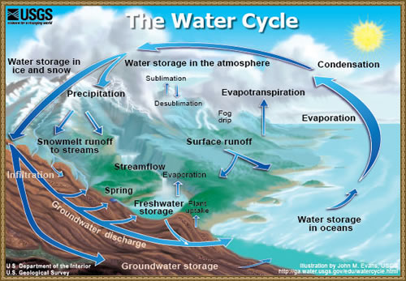
The water cycle is driven by the sun. It heats water in rivers, seas and oceans. Water evaporates into the air. Water can be transpired from vegetation through evapotranspiration. Air currents cause the water vapor to rise. As the air cools the water vapor condenses to form clouds. The condensed water falls as precipitation in the form of rain, sleet, snow or hailstone. Some of this precipitation is intercepted by buildings and vegetation. Precipitation that is not intercepted can then flow over the surface of the earth as surface run-off. This often makes its way to rivers which in turn feeds lakes, seas and oceans. Most run-off infiltrates into the ground. Some is held in storage under the ground whilst other flows through the soils as groundwater flow. Some ground water returns to the surface through springs.
River Basins
A river basin is an area of land drained by a river and its tributaries. River basins have typical features, these include:
Tributaries - smaller rivers flowing into a larger river.
A Watershed - an area of highland surrounding the river basin.
A confluence - where a river joins another river.
Source - the start of a river.
Mouth - Where a river meets a lake, the sea or an ocean.
The diagram below shows these features.
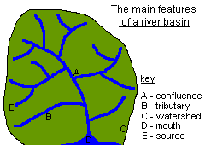
Changes from source to mouth
A river flows from an upland source. Here the velocity of water is faster than downstream because the river's gradient is steep. Near a river's source the valley has a narrow floor and steep sides (v- shaped).
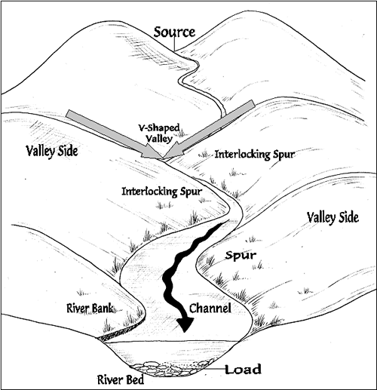
The middle course of the river has a wider floor and the sides of the valley are more gently sloping. The velocity is slower than the upper stage. However, the channel is wider as the amount of water flowing in it increases as other streams and rivers join it.
The lower course of the river is very gentle sloping, almost flat. The channel is usually at its widest and deepest here because the amount of water flowing within the river is at its greatest.
Upper course of a river
In the upper course of a river gradients are steep and river channels are narrow. Vertical erosion is greatest in the upper course of a river. As the result of this typical features include steep valley sides, interlocking spurs, rapids, gorges and waterfalls.
When a river runs over alternating layers of hard and soft rock, rapids and waterfalls may form.
Waterfalls commonly form where water rushes down steep hillsides in upland areas and quickly erodes the rocks. The height and number of waterfalls along a stream or river depends upon the type of rocks that are being eroded by the water. Some types of rocks (shale, for example) wear away more easily than others (such as sandstone or limestone).
As the river or stream wears away the weak rocks, they travel across the surface of stronger rocks. These more resistant rocks become the capstones to waterfalls. The number and thickness of these stronger rock units in a vertical sequence of rocks controls how many water falls there are and how much vertical drop there is on each waterfall.
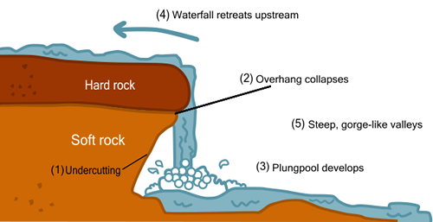
source
The diagram above shows the formation of a waterfall. Soft rock is undercut (1). This leaves a layer of hard rock which overhangs the layer of soft rock (2). The water flows over the overhang and creates a plunge pool in the soft rock below (3). Eventually the overhang will collapse due to the erosion of the soft rock beneath it. The waterfall then retreats up stream (4). This creates a steep, gorge-like valley.
An example of a water fall is High Force in Northumberland. It is located on the River Tees, near Middleton in Teesdale, Tees Valley, England. The waterfall is 20m in height.
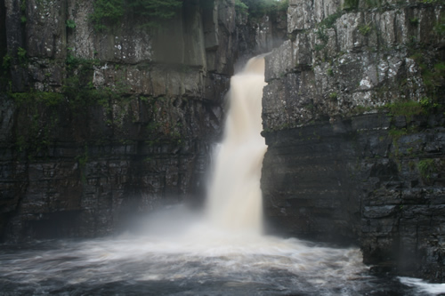
High Force Waterfall
High Force was formed where the River Tees crosses the Whin Sill - a hard layer of rock. The waterfall itself consists of two different types of rock. The upper band is made up of whinstone, a hard rock which the waterfall takes a lot of time to erode. Underlying the whin sill is a layer of of Carboniferous Limestone, a softer rock which is easily worn away by the waterfall. This creates a plunge pool beneath the waterfall. As the limestone is eroded the whin sill is left over hanging the waterfall. Eventually the overhang collapses. This process of erosion means that the waterfall is slowly moving upstream, leaving a narrow, deep gorge in front of it. The length of the gorge is currently about 700 metres. The bed load (rocks that the river is carrying) is mainly composed of large boulders, which are rolled along the river bed. Upstream of the waterfall, the river is narrow; downstream, it widens and meanders.
Middle course of a river
The middle course of a river has more energy and volume then in the upper course. The gradient is more gentle and lateral (sideways) erosion has widened the channel. The river channel has also become deeper. Meanders are typical landforms found in this stage of the river.
Meanders
A meander is a winding curve or bend in a river. They are typical of the middle and lower course of a river. This is because vertical erosion is replaced by a sideways form of erosion called LATERAL erosion, plus deposition within the floodplain.
The image below shows a series of meanders. Notice the deposition on the inside of the meanders (pale material) and the river cliffs or bluffs (indicated by dark shadows) on the outside of the meanders.
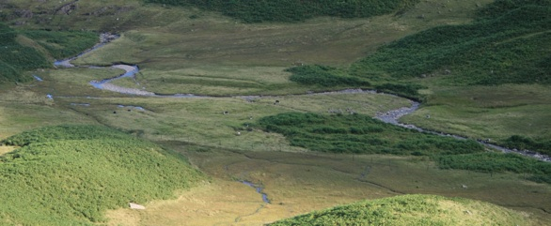
Again, the image below shows a series of meanders. The river shown in the photograph is swollen due to recent rainfall. Once again we can see deposition on the inside curves of the meander.
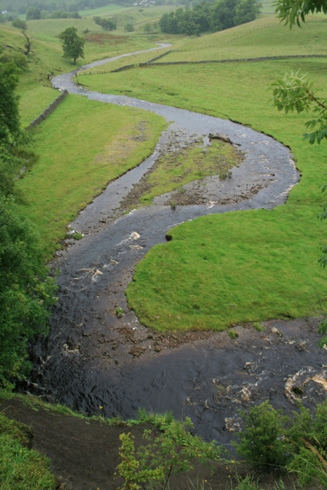
Erosion, transportation and deposition are all processes that create the characteristic features of meanders shown in the images above. There are several stages involved in the creation of meanders. These are discussed below.
Stage 1
In low flow conditions straight river channels have bars of sediment on their beds. Flowing water weavers around these bars of sediment. This creates deeper pathways where most of the water flows called pools and shallow areas where less water flows called riffles. This causes the river flow to swing from side to side.
Stage 2
Where the river swings towards the bank erosion causes undercutting. On the opposite side of the channel where the velocity is lower material is deposited. Therefore the river does not get any wider. The image below shows evidence of undercutting on the outer bank and deposition on the inner bank of the meander. 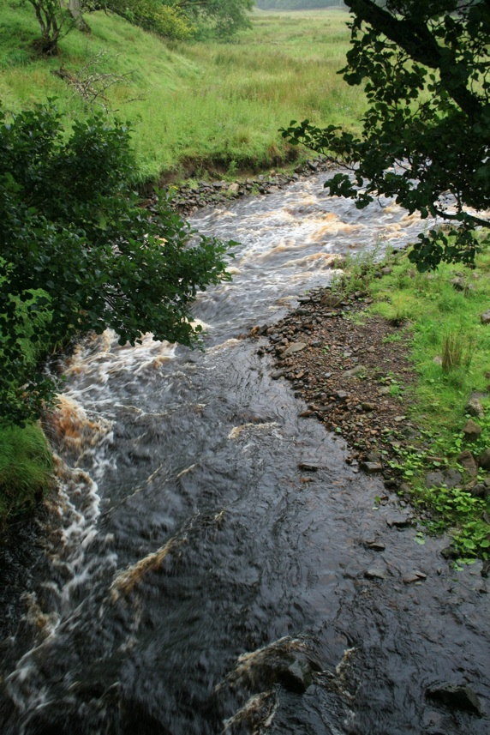
Stage 3
Continued erosion along the outer bank, as the result of hydraulic action and abrasion, creates a river cliff or bluff. A point bar forms on the inner bank. This is a gently sloping deposit of sand, gravel and pebbles. The image below shows a point bar.
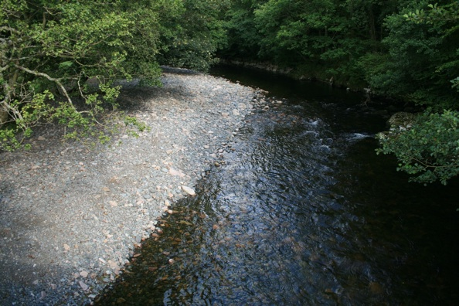
Stage 4
Meanders are perpetuated through a process called helicoidal flow. As the surface flow of water hits the outer bank it corkscrews, flows along the river bed then deposits eroded material on the inner bank.
Step 5
Erosion is greatest beyond the middle of the bend in the meander. This causes the meander to migrate downstream over time. By looking at aerial photographs it is possible to see former channels on the floodplain.
Lower course of a river
The volume of water in a river is at its greatest in the lower course. This is due to the contribution of water from tributaries. The river channel is deep and wide and the land around the river is flat. Energy in the river is at its lowest and deposition occurs. .
Deltas are often found at the mouth of large rivers. An example is the Nile Delta. Deltas are formed when a river deposits material faster than the sea can erode it.
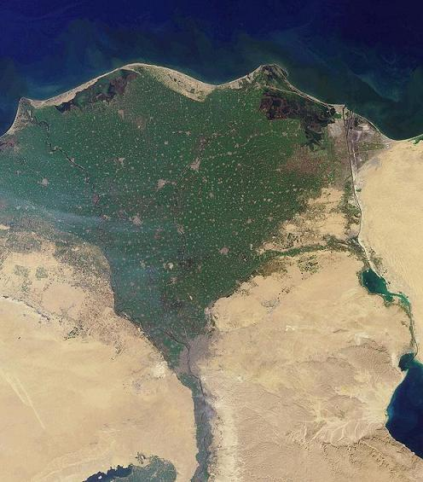
Erosion
Rivers erode in four ways:
Abrasion or corrasion - This is when large pieces of bedload material wear away the river banks and bed.
Attrition - This is when the bed load itself is eroded when sediment particles knock against the bed or each other and break, becoming more rounded and smaller.
Hydraulic Action - This is when the force of water erodes softer rock.
Solution or corrosion - This is when acidic water erodes rock.

Transportation
Rivers transport material in four ways:
- Solution - minerals are dissolved in the water and carried along in solution.
- Suspension - fine light material is carried along in the water.
- Saltation - small pebbles and stones are bounced along the river bed.
- Traction - large boulders and rocks are rolled along the river bed.
Deposition
Deposition occurs when a river loses energy. This can be when a river enters a shallow area or towards its mouth.
Flooding
Floods can bring both advantages and disadvantages to an area. Floods can deposit rich, fertile alluvium on agricultural areas. Also, flood water can replenish irrigation channels. On the other hand floods can destroy food supplies, homes and transport infrastructures.
Causes of flooding
Human causes:
Deforestation - Cutting down trees causes increased run-off (water flowing over the surface of the earth). Rain water reaches rivers faster. Flooding becomes more likely.
Urbanisation - Man-made surfaces such as concrete result in greater run-off. Rain water reaches rivers faster and can cause flooding.
Natural causes:
Heavy rainfall
Melting snow
Solutions to flooding
Afforestation - Planting more trees reduces run-off and increases interception.
Dams - Although very expensive, dams can significantly reduce the risk of flooding downstream
Case Study - Ganges/Brahmaputra River Basin
Flooding is a significant problem in the Ganges/Brahmaputra river basin. They cause large scale problems in the low lying country of Bangladesh. There are both human and natural causes of flooding in this area.
Human Causes
Deforestation - Population increase in Nepal means there is a greater demand for food, fuel and building materials. As a result deforestation has increased significantly. This reduces interception and increases run-off. This leads to soil erosion. River channels fill with soil, the capacity of the River Ganges and Brahmaputra is reduced and flooding occurs.
Natural Causes
Monsoon Rain
Melting Snow
Tectonic Activity - The Indian Plate is moving towards the Eurasian Plate. The land where they meet (Himalayas) is getting higher and steeper every year (fold mountains). As a result soil is becoming loose and is susceptible to erosion. This causes more soil and silt in rivers. This leads to flooding in Bangladesh.

