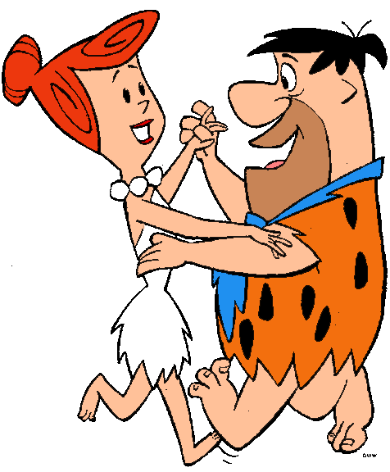

Section 1: Why do we use quarries?

1. Name the most common rock that is mined using a quarry? ___________________________ (1 mark)

2. Give another name for this rock. ______________________________________ (1 mark)

3. Give 3 uses of Limestone.

* _______________________________________
* _______________________________________
* _______________________________________

(3 marks)

Name__________ P6 The effects of quarrying



Section 2: What is a quarry?

4. Looking at the pictures of a limestone quarry, how would you **describe** it? _____________________________________________

________________________________________ (1 mark)

5. How is the limestone obtained from the Earth’s crust in **large quantities**? _____________________________________________

________________________________________ (1 mark)

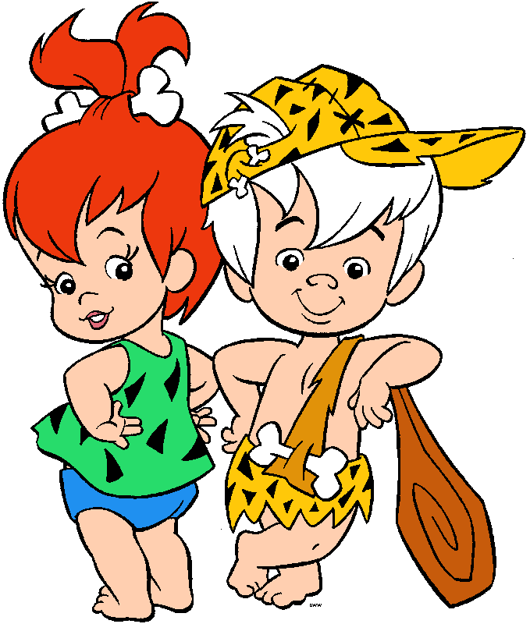

6. How is the limestone **transported** from the quarry to be processed? _______________________________ (1 mark)

Section 3: The problems with quarrying.

**Problem 1**

The pictures are showing

_____________________________________________

__________________________________________________ (1 mark)

This could be a problem because _____________________________________________

_____________________________________________

_______________________________________ (1 mark)

**Problem 2**

The pictures are showing _____________________________________________

_______________________________________ (1 mark)

This could be a problem because _____________________________________________

_____________________________________________

_______________________________________ (1 mark)

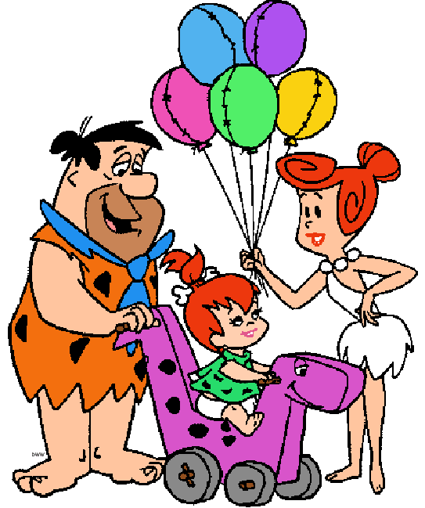

**Problem 3**

The pictures are showing _____________________________________________

_______________________________________ (1 mark)

This could be a problem because _____________________________________________

_____________________________________________

_______________________________________ (1 mark)

**Problem 4**

The pictures are showing _____________________________________________

_______________________________________ (1 mark)

This could be a problem because _____________________________________________

_____________________________________________

_______________________________________ (1 mark)

Having highlighted the problems associated with quarrying for limestone, can you think of an **advantag**e of having a quarry near to where you live?

___________________________________________

___________________________________________

___________________________________________

_____________________________________ (1 mark)



17