Population and settlement test
1 (a) Study Table 1, which shows information about the population and area of selected regions in
China.
Table 1

Region | Population (millions) | Area (square km) | Population Density (per square km)
Guizhou | 38 | 176 100 | 216
Hubei | 60 | 187 400
Jiangsu | 74 | 102 600 | 721
Qinghai | 6 | 720 000 | 8
Shandong | 91 | 153 000 | 595
Xinjiang | 19 | 1 600 000 | 12

(i) List the following regions of China from the highest to the lowest population density.

Guizhou Qinghai Shandong

[1]

(ii) Calculate the population density of Hubei (in people per square km). You must show your calculations. [2]

(iii) Xinjiang is a highland region. Referring to physical factors, explain why some highland regions are sparsely populated. [3]

(iv) Jiangsu is a coastal region. Referring to economic and human factors, explain why many coastal regions are densely populated. [4]

(b) Study Fig. 1, which shows information about population.

over-population
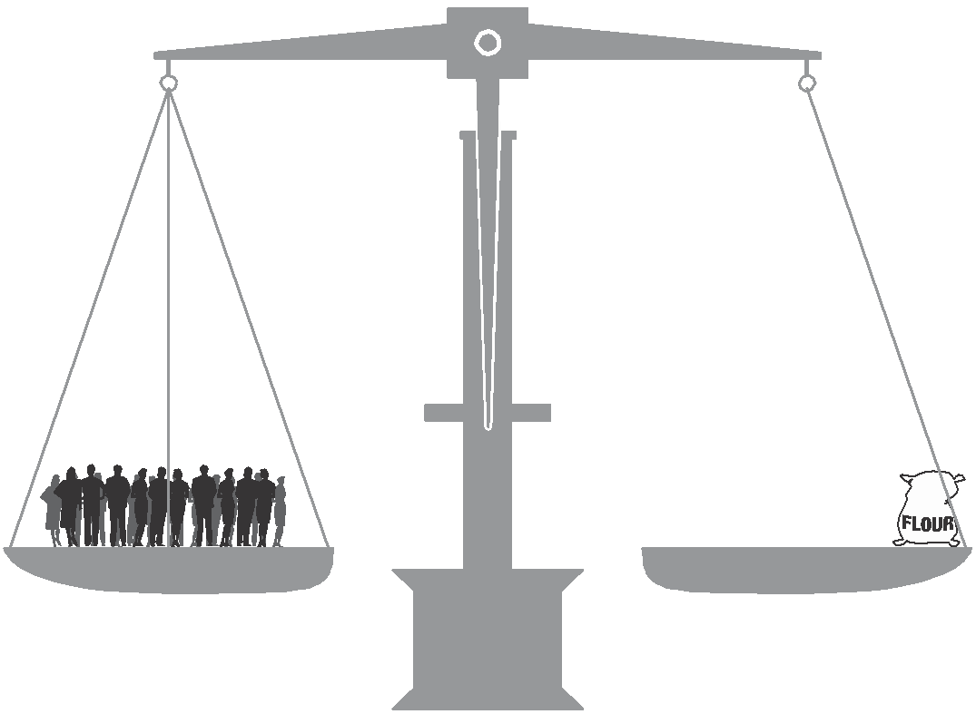

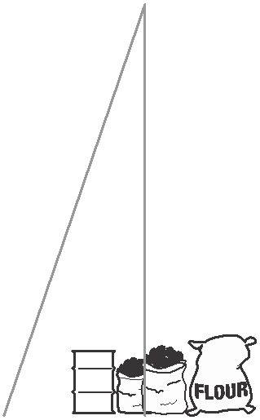

optimum population
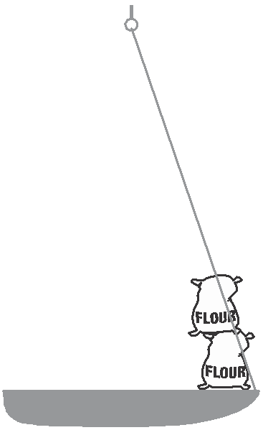

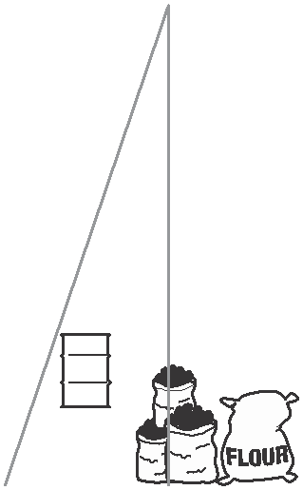

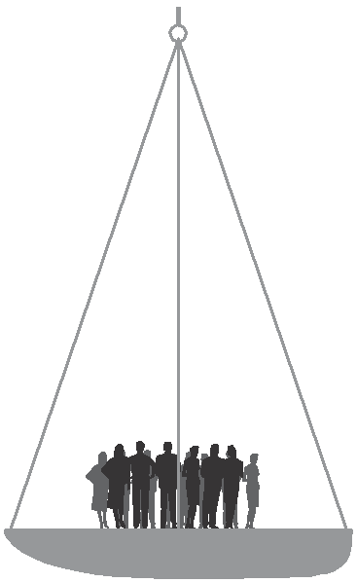

(i) Suggest the likely effects of under-population on the economy of a region. [3]

(ii) Explain the problems over-population may cause for the people and natural environment of a region. [5]

(c) For an example of international migration which you have studied, explain why many people made the decision to migrate. You should name the countries between which people migrated and refer both to pull and to push factors. [7]

[Total: 25 marks]

2 The city of Cambridge in the UK lies close to important transport routes. People commute to work in the CBD from the suburbs and surrounding villages. The city suffers from traffic congestion.

Fig. 4 below shows features of the transport routes in and around Cambridge.

Fig. 4

to
Birmingham
to Ely

A428

N
P P
CBD

P
A1303 to

CAMBRIDGE
Harwich

P P

to London to
London 0 2 4 6
Melbourn km

Key

P

motorway and dual carriageway other main road
car park with bus to CBD built up area

CBD

central business district

railway and station

7

(a) What features, shown on Fig. 4, help reduce traffic congestion for long distance travellers who do not wish to visit Cambridge?

....................................................................................................................................

....................................................................................................................................

....................................................................................................................................

.................................................................................................................................... [2]

(b) (i) Find the village of Melbourn on Fig.4. A commuter travels from Melbourn to
Cambridge CBD.

Estimate the distance, to the nearest kilometre, that the commuter travels.

………………………………… kilometres

State the compass direction in which the commuter travels.

…………………………………[2]

(ii) Describe and give a reason for the location of the car parks shown on Fig. 4.

............................................................................................................................

............................................................................................................................

............................................................................................................................

...........................................................................................................................

............................................................................................................................

............................................................................................................................. [3]

(c) Suggest one way of reducing traffic congestion caused by commuters from the suburbs of Cambridge.

....................................................................................................................................

....................................................................................................................................

..................................................................................................................................... [1]
[Total: 8 marks]

1 (a) Fig. 1 was produced by the United Nations. It shows the actual growth in the world’s population by 1999. It also shows that the world’s population may grow in three possible ways by 2050 (estimates X, Y and Z).
(i) Describe fully what the graph shows about population growth. [3]
(ii) How and why do the two estimates for future population growth X and Y differ? [2]
(iii) Suggest why the future growth of the world’s population might be as shown by estimate Z. [2]

(b) With reference to examples you have studied, explain why

(i) changes may occur in countries from time to time in

A the birth rate

B the death rate [7]

(ii) governments may be concerned by a rapid growth of population. [5]

(c) Describe the main features of the population pyramid of a developing country shown in Fig. 2 and suggest reasons for these features. [6]

Fig. 1
Total world population (actual and estimated 1950–2050)

11
10 6 billion
World population (billion)
11
X 10
World population (billion)
Key

up to 1999

9 (1999) Y 9
8 Z 8
7 7
6 6
5 5
4 4
3 3
2 2
1 1
high estimate (X)
medium estimate (Y)
low estimate (Z)
Fig. 2

Males
80+
80 – 84
75 – 79
70 – 74
65 – 69

60 – 64
55 – 59
50 – 54
45 – 49
40 – 44
35 – 39
30 – 34
25 – 29
20 – 24
15 – 19
10 – 14
5 – 9
0 – 4

Females

65 years

15 years

8 6 4

2 0 0

Percentage

2 4 6 8

2 (a) Fig. 3 (below) shows part of a large urban area in a developed country. With the help of information from Fig. 3 and other facts you may know, suggest reasons for each of (i), (ii) and (iii):

(i) the location of

A the large superstore/hypermarket labelled X, [4]

B the district shopping centre labelled Y, [3]

(ii) differences in the numbers and distribution of different types of shopping
areas shown, [3]

(iii) the different road pattern in area Z when compared with the road pattern in other residential areas further away from the CBD. [2]

(b) Choose two of the following types of urban land use (I–III);

I leisure centre or sports ground,

II bus and railway stations,

III offices.

Referring to a named town or city you know well, describe and explain the distribution of your chosen urban land uses. [4,4]

(c) The area surrounding towns and cities is known as the rural-urban fringe. An example of this area is shown on Fig. 3. Why do many town and city authorities control the developments which may take place in the rural-urban fringe? [5]

u

X

Y

N

AREA Z

edge of
CBD

0 1

CBD

2

Key

Selected important roads
Mainly residential land use
Boundary of built-up area

Single shops
shopping areas

Rows of local shops

District shopping centres

Kilometres

Superstore/hypermarket

