[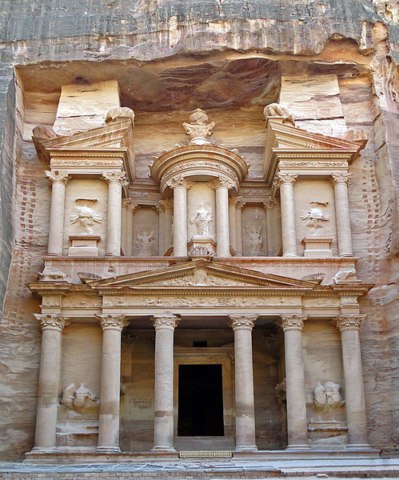](http://upload.wikimedia.org/wikipedia/commons/9/94/Al_Khazneh.jpg)Petra (Jordan)

**Location:** Ma’an, Jordan.

**Built:** Around 2600 years ago possibly by the Egyptians although no one is completely sure.

**Importance:** The site remained unknown until 200 years ago when a Swiss explorer found it. For 2400 years no one from Europe knew about this amazing site!

**Tourism:** Around 29,000 people visit the ancient city of Petra every month.

[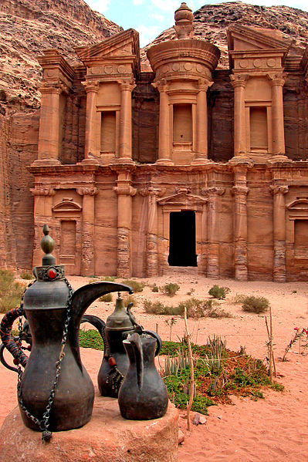](http://upload.wikimedia.org/wikipedia/commons/f/fd/The_Monastery_(Al_Dier),_Petra.jpg)[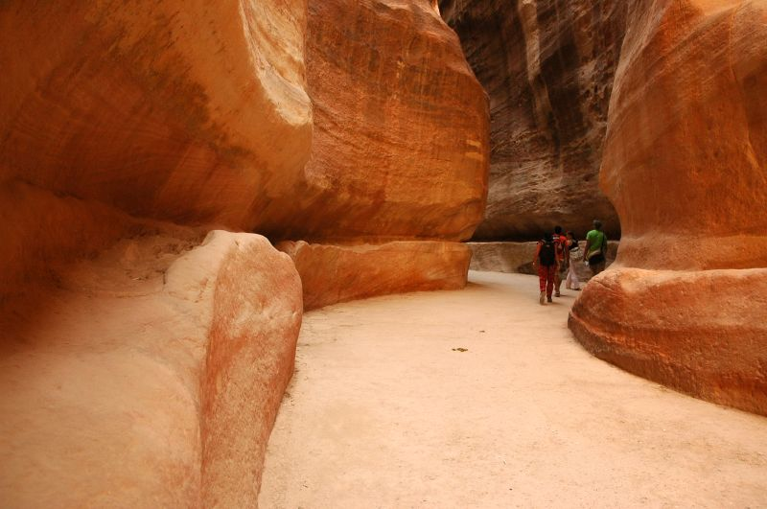](http://upload.wikimedia.org/wikipedia/commons/5/5f/Petra-Roman-Aqueduct.jpg)

“I couldn’t believe that something so amazing was so old. It was almost scary!”

Can you think what this old poem is saying about Petra?

“It seems no work of Man's creative hand, by labour wrought as wavering fancy planned;

But from the rock as if by magic grown, eternal, silent, beautiful, alone!

Not virgin-white like that old Doric shrine, where erst Athena held her rites divine;

Not saintly-grey, like many a minster fane, that crowns the hill and consecrates the plain;

But rose-red as if the blush of dawn, that first beheld them were not yet withdrawn;

The hues of youth upon a brow of woe, which Man deemed old two thousand years ago,

match me such marvel save in Eastern clime,

a rose-red city half as old as time.”

What can you see?

Visitors can wander through the ancient town and marvel at the amazing structures.

The walk takes visitors through strange rock formations like that to the left.

Tourism: Jordan

[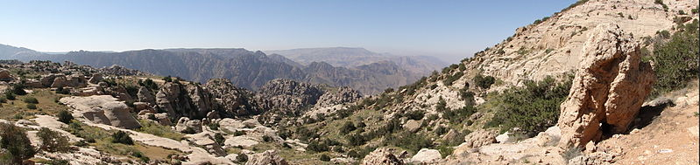](http://upload.wikimedia.org/wikipedia/commons/0/06/Dana_Reserve_08.jpg)

Why do people visit Jordan?

Jordan is an amazing country with a rich history. There is so much to see. There are also amazing landscapes like that above to explore.

In 2010 8 million people visited Jordan from all over the world. This gave about 3.5 billion pounds to the economy of Jordan!

[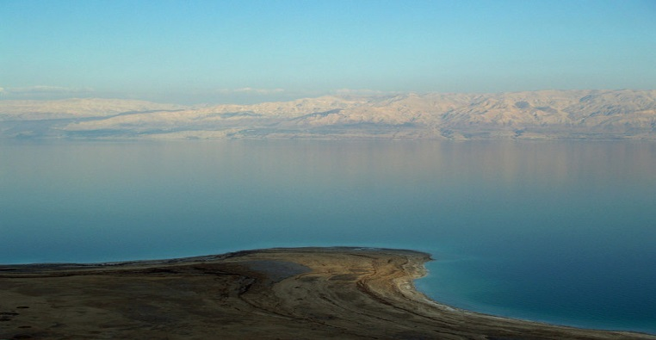](http://upload.wikimedia.org/wikipedia/commons/2/21/Dead_Sea_by_David_Shankbone.jpg)[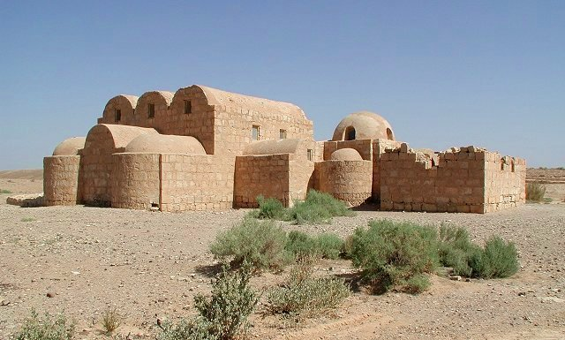](http://upload.wikimedia.org/wikipedia/commons/5/53/Qasr_Amra.jpg)

What impacts do you think tourism could have on Jordan and the Red Sea?

**The Dead Sea**

Many people visit the dead sea from Jordan due to its medical properties. Some hotels have now been built on its shores.

**Qasr Amra**

A desert castle in Jordan built by the Islamic Empire