Generating electricity

Fossil fuels:
The fossil fuels are coal, oil and natural gas. They are fuels because they release heat energy when they are burned. They are fossil fuels because they were formed from the remains of living organisms millions of years ago. About 75% of the electricity generated in the UK comes from power stations fuelled by fossil fuels.
Coal provides around 28% of the world’s energy. New technologies use limestone to ‘clean’ coal (designed to reduce CO₂ emissions). Gypsum is formed as a by-product which can be used in the construction industry.
Crude Oil provides around 40% of the world’s energy. It is easier to get out of the ground than coal (as it can flow along pipes). This makes it cheaper to transport.
Natural Gas provides around 20% of the world’s energy. It is burnt in power stations as well as being used to heat homes. It is easy to transport along pipes.

Advantages of using fossil fuels
- Very large amounts of electricity can be generated in one place using coal, fairly cheaply.
- Transporting oil and gas to the power stations is easy.
- Gas-fired power stations are very efficient.
- A fossil-fuelled power station can be built almost anywhere, as long as you can get large quantities of fuel to it. Didcot power station, in Oxfordshire, has a dedicated rail link to supply the coal.

Disadvantages of using fossil fuels
- Fossil fuels are non-renewable energy resources. Their supply is limited and they will eventually run out. Fossil fuels do not renew themselves, while fuels such as wood can be renewed endlessly.
- Fossil fuels release carbon dioxide when they burn, which adds to the greenhouse effect and increases global warming. Of the three fossil fuels, for a given amount of energy released, coal produces the most carbon dioxide and natural gas produces the least.
- Coal and oil release sulphur dioxide gas when they burn, which causes breathing problems for living creatures and contributes to acid rain.
- Mining coal can be difficult and dangerous. It can also destroy large areas of landscape.
- Coal-fired power stations need huge amounts of fuel, which means train-loads of coal almost constantly. In order to cope with changing demands for power, the station needs reserves.
This means covering a large area of countryside next to the power station with piles of coal.

Generating electricity
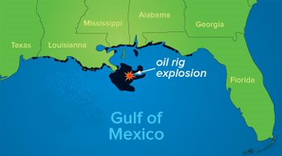
Case study: fossil fuels
On 20 April 2010, the Deepwater Horizon drilling rig exploded in the Gulf of Mexico, killing 11 workers and causing an oil spill that soon became the worst environmental disaster in US history.

What happened?
A new well had just been drilled. Suddenly, some natural gas and oil accidentally escaped from the well and gushed to the surface, ignited and exploded in a huge fireball.

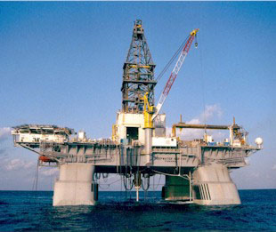
Most of the workers escaped by lifeboat, but sadly 11 workers were never found and are thought to have died in the explosion.

After burning for 36 hours the damaged platform sank. A broken pipe began leaking oil into the Gulf of Mexico.

86 days later, after several failed attempts (including covering it with metal and filling it with rubbish and mud) the leaking pipe was finally capped using cement. It is estimated that up to 4.9 million barrels worth of oil leaked into the Gulf of Mexico.

The effects
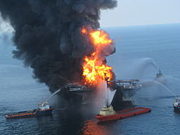
The oil spill had a huge impact on local wildlife – it is thought that thousands of birds, fish and crustaceans (crabs etc), as well as hudreds of sea turtles and dolphins were killed.
Environmental groups fought to save their lives, and many animals were cleaned and released.

The oil spread to the marshes and wetlands of Louisiana, and many of the ecosystems were destroyed.

Surrounding beaches were closed following the accident and consequently tourism has decreased in the area.
The Deepwater Horizon rig
before and after the explosion
Fishing waters were also closed and many fishermen lost out on wages, with problems still affecting them over a year later.

It is estimated that the cost of cleaning up after the disaster could reach £60 billion.
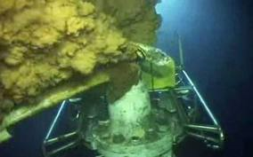
Generating electricity

Nuclear fission:
The main nuclear fuels are uranium and plutonium. These are radioactive metals. Nuclear fuels are not burnt to release energy. Instead, the fuels are involved in nuclear reactions in the nuclear reactor, which leads to heat being released.
Nuclear fission involves neutrons smashing into the nucleus of the uranium atoms, which split roughly in half and release energy in the form of heat.
The rest of the process of generating electricity is then identical to the process using fossil fuels. The heat energy is used to boil water. The kinetic energy in the expanding steam spins turbines, which then drive generators to produce electricity.
The first large-scale nuclear power station opened at Calder Hall in Cumbria, England, in 1956.
Some military ships and submarines have nuclear power plants for engines.
Nuclear power produces around 11% of the world's energy needs, and produces huge amounts of energy from small amounts of fuel, without the pollution that you'd get from burning fossil fuels.

Advantages of using nuclear fission
- Nuclear power costs about the same as coal, so it's not expensive to make.
- Does not produce smoke or carbon dioxide, so it does not contribute to the greenhouse effect.
- Produces huge amounts of energy from small amounts of fuel.
- Produces small amounts of waste.
- Nuclear power is reliable.

Disadvantages of using nuclear fission
- Like fossil fuels, nuclear fuels are non-renewable energy resources.
- Although not much waste is produced, it is very, very dangerous. It must be sealed up and buried for many thousands of years to allow the radioactivity to die away. For all that time it must be kept safe from earthquakes, flooding, terrorists and everything else. This is difficult.
- Nuclear power is reliable, but a lot of money has to be spent on safety - if it does go wrong, a nuclear accident can be a major disaster. People are increasingly concerned about this - in the 1990's nuclear power was the fastest-growing source of power in much of the world. In 2005 it was the second slowest-growing.

Generating electricity
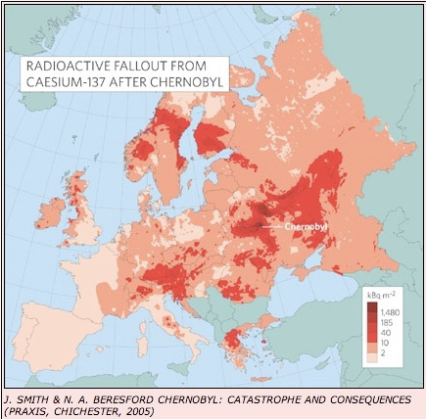
Case study: nuclear fission
On 26 April 1986, one of four nuclear reactors at the Chernobyl power station in Ukraine exploded.
Contamination is still a problem and disputes continue about how many will eventually die as a result of the world's worst nuclear accident.
What happened?
The accident happened during a routine test. Prior to the test, the automatic shutdown mechanisms were disabled. Coolant water was reduced and the power output was increased. The operator tried to shut down the reactor but a flaw in the design caused a large power surge.
It was too late to turn the shutdown system back on. The reactor’s roof was blown off and radioactive material was blasted out of the top. A fire started which burned for nine days.

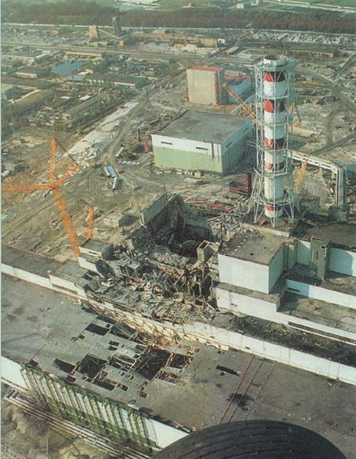
Because the reactor was not in a reinforced concrete shell, as is standard practice in most countries, the building sustained severe damage and large amounts of radioactive debris escaped into the atmosphere.
Firefighters crawled onto the roof of the reactor building to fight the blaze while helicopters dropped sand and lead in an effort to control the radiation.

The effects
The disaster released at least 100x more radiation than the atom bombs dropped on Nagasaki and Hiroshima.
Much of the fallout was deposited close to Chernobyl, in parts of Belarus, Ukraine and Russia.
Contamination with caesium and strontium is of particular concern, as it will be present in the soil for many years.
After the accident traces of radioactive deposits were found in nearly every country in the northern hemisphere.
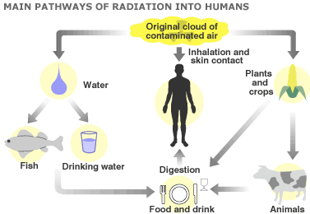
But wind direction and uneven rainfall left some areas more contaminated than their immediate neighbours. Scandinavia was badly affected and there are still areas of the UK where farms face post-Chernobyl controls.
In the short-term, 28 reactor staff and emergency workers died from acute radiation sickness.
Pregnant women near Chernobyl have a higher risk of giving birth to stillborn or deformed babies, or babies with genetic problems like Down syndrome.

As of 2005, it is thought that hundreds of thousands of people have suffered from cancer, particularly thyroid cancer and leukaemia, due to the disaster.

