Key discussion topics for today’s lesson
- Use of oil and other fossil fuels enabled the industrial revolution in Europe and America, so we should not discourage oil use in less economically developed countries.
- Destruction is an unfortunate side-effect of development but modern technology can lessen its effects.
- The oil industry and businesses relying on oil should pay to sort out destruction such as oil spills and air pollution caused by their development or use of oil.

Oil Extraction in the Niger Delta
Background Information – Oil Production
- Nigeria is Africa’s leading producer of oil
- Shell accounts for over half of Nigeria’s oil production
- In 2005 131 Million tonnes of oil were produced, almost all of this was exported
- Oil represents 90% of Nigeria’s exports by value, a potential economic weakness
Background Information – Niger Delta Ecosystem
- Nigeria’s largest surviving area of rainforest
- Accounts for 150 species of fish as well as spectacular mammals, primates, reptiles and insects
- Mangrove forests dominate the delta
- 60% of West Africa’s fish stocks spawn in the delta
- Despite the diversity the ecosystem is fragile and sensitive to change
- For thousands of years people had used the environment sustainably
- 23 Million people now live in the six states that make up the delta
Impact of oil and gas production
Environmental degradation and conflict with indigenous people
- Over 4000 oil spills recorded since 1958
- In 2006 WWF described the area as one of the 5 most polluted on the planet
- 500 Million tonnes of oil have been lost to spillage ($10 Million a day!)
- These spills have destroyed wildlife
- Worst in Ogoniland in southernmost part of the delta, the region has 100 oil wells, two refineries and a petrochemical facility
- In 2001 an especially bad spill hit the area causing fires that burned for 3 months
“When oil spills here those of us who use the mangroves to harvest periwinkles and other sea food suffer. The oil affects the growth and development of the forest and its resources. When the water is polluted, they all die” – an Ogoniland Fisherwoman
- As well as the spills the flaring of natural gas has been blamed for crop failure, cancer and respiratory problems amongst the local people.
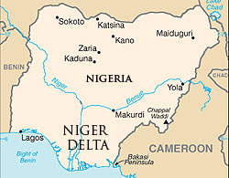
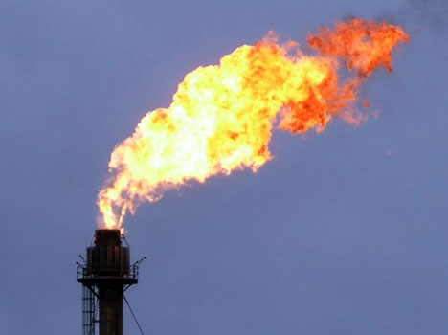
The causes of environmental degradation
- 6000km of ageing pipelines cross the Niger Delta, this above ground network corrodes quickly in the hot, humid climate
- Pipelines cross fields, villages and gardens so can have devastating consequences when they leak
- Local people blame the negligence of the oil companies for so much of the pollution in the region
- Oil companies accept same blame but also say sabotage of the pipelines contributes to the problem
- Estimates suggest 10% of oil is lost to illegal tapping making the oil companies reluctant to compensate for spillages
- Nigeria’s population boom is also to blame, in 1958 population was 38 Million, today it is 135 Million putting acute pressure on environmental resources and causing deforestation
- The urbanisation of places such as Port Harcourt and Warri has also had a part to play
Economic Issues
- The region only received 1% of the revenues generated by oil and natural gas production although this has now risen to 13%. Still a long way from equality
- Local people continue to lack the most basic of services such as health care, schools, running water and electricity
- More traditional economic activities such as agriculture and fishing have been forced out of the area with oil and natural gas production dominating the Delta

Further Information
http://news.bbc.co.uk/1/shared/spl/hi/picture_gallery/04/africa_polluting_nigeria/html/1.stm - Images and descriptions of the region
http://www.ngdelta.com/corp.html - mission statement of the Niger Delta Exploration and Production company
http://www.cnn.com/2012/10/11/world/europe/netherlands-nigeria-shell-oil - local people sue Shell
http://www.guardian.co.uk/environment/2011/aug/04/niger-delta-oil-spill-clean-up-un - clean-up of the region will take 30 years

