Machu Pichu

[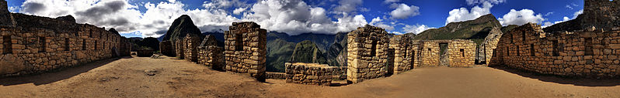](http://upload.wikimedia.org/wikipedia/commons/e/e7/89_-_Machu_Picchu_-_Juin_2009.jpg)[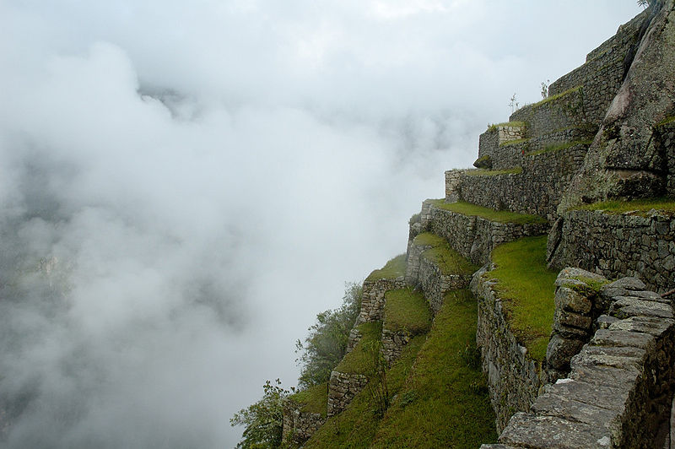](http://upload.wikimedia.org/wikipedia/commons/a/a9/MachuPicchu_TerracedFields_(pixinn.net).jpg)[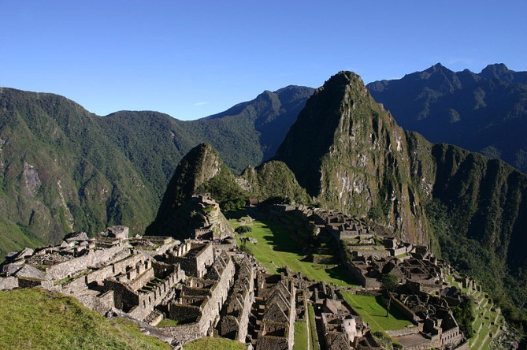](http://upload.wikimedia.org/wikipedia/commons/7/7e/Machu_Picchu_early_morning.JPG)

The Residential Section

Visitors can walk around the areas where the Incas used to live.

Just imagine taking in the atmosphere and the air where this amazing civilisation lived. What would you imagine the people were doing?

What can you see there?

Visitors need to take the 2 hour walk up the mountains to the site of Mach Pichu. The views of the landscape are stunning and well worth it!

Visitors are able to walk around the remains which show how the Inca’s used advanced techniques for farming and building.

Who were the Inca People?

The Inca’s were an amazing civilisation who lived in Peru before the Europeans invaded. They are believed to have formed their empire all the way back in 1482. They had a great empire and government based in Peru and were amazing builders- That’s why we can still admire their work today!

**Location:** Near Cusco, Peru.

**Built:** Around 1450 by the Inca Empire

**Importance:** The former Inca town is in remarkably good condition and can hold clues to the mysteries of these people

**Tourism:** 400,000 people visited the site in the year 2000. This has been rising since.

[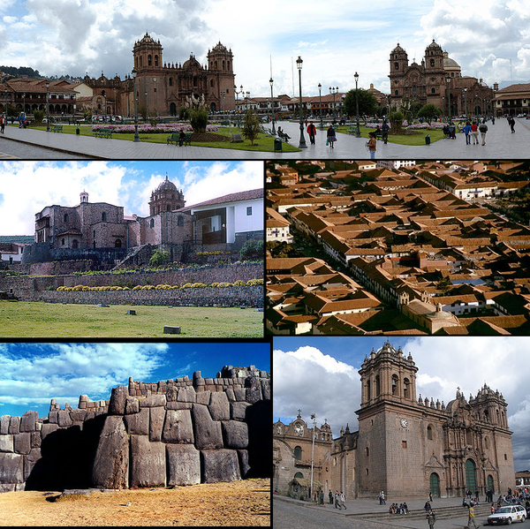](http://upload.wikimedia.org/wikipedia/commons/4/42/Cuscoinfobox.png)Tourism

What else is there to do nearby?

* The nearby town is Cuzco is an explorers paradise!
* The town is so popular it even has its own international airport.
* The cathedral was built all the way back in 1539 and visitors can still go inside.

Tourism

Entrance has been restricted to 2,500 people per day

Why do you think they felt the need to do this?

I took the breath-taking (literally) 2 hour walk from Cuzco. It was incredible to see such an important landmark.