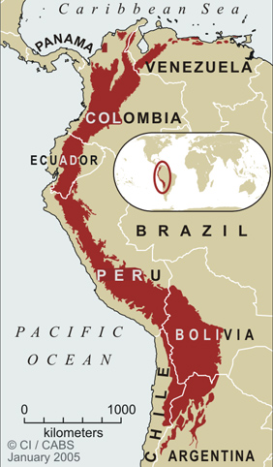
Tropical Andes Hotspot
One of the richest and most diverse regions on Earth, about 5% of all plant species are endemic to the Tropical Andes region.
A unique plant species is an Andean bromeliad that requires 100 years to mature. The threatened yellow-eared parrot, yellow-tailed woolly monkey and spectacled bear are all endemic to the Tropical Andes.
This hotspot also maintains the largest variety of amphibians in the world, with 664 distinct species. Unfortunately, almost 450 amphibian species are listed as threatened on the 2004 IUCN Red List.
Although a quarter of its habitat still remains, the region is facing a variety of threats including mining, timber extraction, oil exploration, and narcotics plantations, which are all expanding due to the continual growth of many large cities in the region. The cloud forests are facing increased pressure from hydroelectric dams, and invasive species like the American bullfrog and grasses for cattle grazing are becoming problems as well.
Madagascar Hotspot
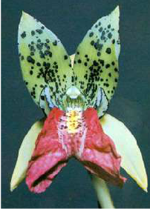
One of the largest and most impressive trees is the baobab. It can grow to a circumference of 70 feet, and is common in the drier, western half of Madagascar. Baobab trees can live over 800 years. There are 8 species of baobab in the world, and 6 of these are endemic to Madagascar. This is typical of the plant life: 80% of the plant species here are unique.
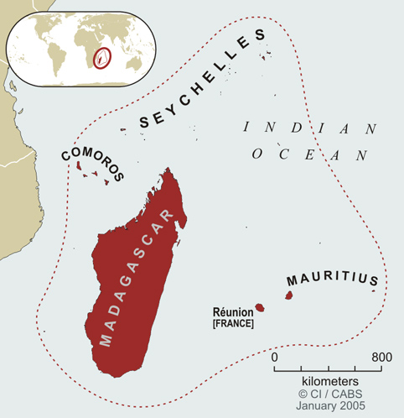
Madagascar is rich in orchids, like this Cymbidiella which is unique to the island. There are over 1,000 species of orchid native to Madagascar, and more species are discovered regularly. Most of the orchids grow in rainforest. Since humans arrived in Madagascar roughly 2,000 years ago, much of the original forest has been chopped down.

Indonesia Hotspot

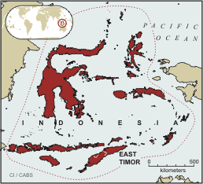
The spectacular flora and fauna of the Indonesia (Sundaland) Hotspot are succumbing to the explosive growth of industrial forestry in these islands and to the international animal trade that claims tigers, monkeys, and turtle species for food and medicine in other countries.
Populations of the orangutan, found only in this hotspot, are in dramatic decline. Some of the last refuges of two Southeast Asia rhino species are also found on the islands of Java and Sumatra.
Like many tropical areas, the forests are being cleared for commercial uses. Rubber, oil palm, and pulp production are three of the most detrimental forces facing biodiversity in the Sundaland Hotspot.
Mediterranean Hotspot
The flora of the Mediterranean Basin is dramatic. Its 22,500 endemic plant species are more than four times the number found in all the rest of Europe; the hotspot also supports many endemic reptile species.
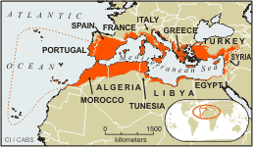
As Europe’s vacation destination, populations of threatened species (e.g. Spanish Imperial eagle) are increasingly fragmented and isolated to make way for resort development and infrastructure. The Mediterranean monk-seal, the barbary macaque and the Iberian lynx, which is Critically Endangered, are among the region’s imperiled species.

Polynesian Hotspot
Comprising 4,500 islands stretched across the southern Pacific Ocean, the Polynesia-Micronesia hotspot is the epicenter of the current global extinction crisis.
Twenty-five bird species have gone extinct here since the arrival of the Europeans 200 years ago, victims of introduced invasive species and over-hunting. The spectacular endemic honeycreepers and other forest birds of the Hawaiian Islands are among those that are seriously threatened but still surviving in this hotspot, e.g. Hawaiian Silver sword plants
