The Great Wall of China

[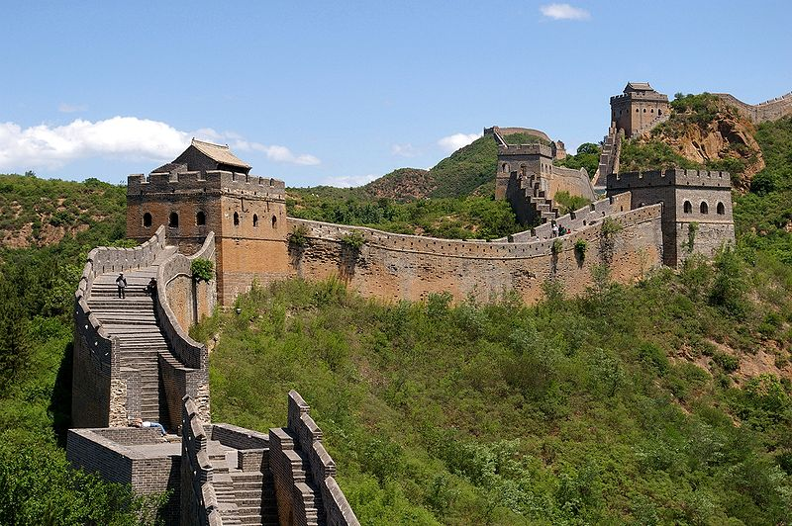](http://upload.wikimedia.org/wikipedia/commons/1/10/20090529_Great_Wall_8185.jpg)

**Location:** Extends from Kansu in the west, to the Yellow sea, in the east.

**Built By:** Various Chinese dynasties (powerful families).   
  
**Importance:** It is the largest man-made structure in the world stretching approximately 5,500 miles.

**Tourism:** The length of the Great Wall makes it a very popular attraction. Many people visit to learn about its history.

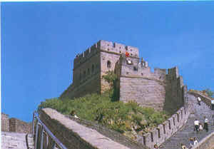

What was it for?

The wall was originally constructed as a barrier against invaders such as the Mongolians. It began as a series of smaller walls which were then joined to fend off further invasions.   
  
The wall was rebuilt and modified throughout history by the ruling Chinese families.

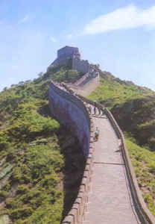

What is there to see?

The immense size and length of the wall make it a popular tourist attraction. If you followed the path of the wall you would pass through many different regions of China.  
  
About 3,000,000 people visit the Great wall each year to admire the architecture and learn about its history.

China: Tourism

[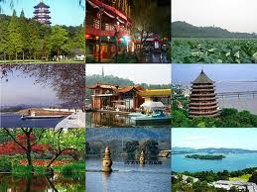](http://www.google.co.uk/imgres?q=why+go+to+china&um=1&hl=en&safe=active&sa=N&biw=704&bih=775&tbm=isch&tbnid=slqkwNF-8GM2hM:&imgrefurl=http://blog.imogenheap.com/post/11649835006/thoughts-from-flight-ua-857&docid=nr7jIcEXj44yBM&imgurl=http://3.bp.blogspot.com/-zT6g0tMOvAs/Tc56XNbqt8I/AAAAAAAAAH0/2-jGYGmp2BY/s1600/Hangzhou_west_lake.jpg&w=512&h=384&ei=z5OeT8HSAYzb8gOwhPDyDg&zoom=1&iact=hc&vpx=110&vpy=240&dur=1011&hovh=194&hovw=259&tx=170&ty=110&sig=118202481617076278241&page=3&tbnh=134&tbnw=202&start=34&ndsp=18&ved=1t:429,r:15,s:34,i:184)

China is one of the most ancient countries in the world with over 5000 years of history.  
  
Chinese food is very popular with tourists as it is extremely varies. Every region has its own specialities.  
  
Thousands of people travel to China to admire the wildlife which include giant pandas and Siberian tigers.

[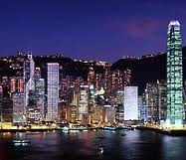](http://www.google.co.uk/imgres?q=hong+kong&um=1&hl=en&safe=active&sa=N&biw=704&bih=775&tbm=isch&tbnid=tkyfKfOya5awQM:&imgrefurl=http://www.nationsonline.org/oneworld/hong_kong.htm&docid=btmCCsGdClcmGM&imgurl=http://www.nationsonline.org/gallery/Hong-Kong/Hong_Kong_Skyline.jpg&w=234&h=202&ei=FpmeT9nXKoX08QPjq-X1Dg&zoom=1&iact=hc&vpx=252&vpy=376&dur=324&hovh=161&hovw=187&tx=69&ty=102&sig=118202481617076278241&page=1&tbnh=134&tbnw=167&start=0&ndsp=12&ved=1t:429,r:10,s:0,i:90)

**Highlights**

* Visit to the Forbidden City, Tiananmen Square and the Temple of Heaven in Beijing
* Hike remote sections of the Great Wall
* View the Terracotta Warriors in Xian
* Explore the ancient World Heritage town Lijiang and surrounding villages
* Hike the spectacular scenic Tiger Leaping Gorge
* Immerse yourself in the vibrant city of Hong Kong

Read more: <http://www.lonelyplanet.com/china/tours/trekking/hike-bike-china#ixzz1tX1L4Fvj>

C:\Program Files\Microsoft Office\MEDIA\CAGCAT10\j0297551.wmf

“We took the cable car to the entrance to the wall - it is an **amazing** structure! It is a very steep climb once you are on the wall and the terrain is rough and the steps steep and uneven so pack good shoes.   
  
The views are stunning and the wall extends so far. It is a truly unforgettable experience.”