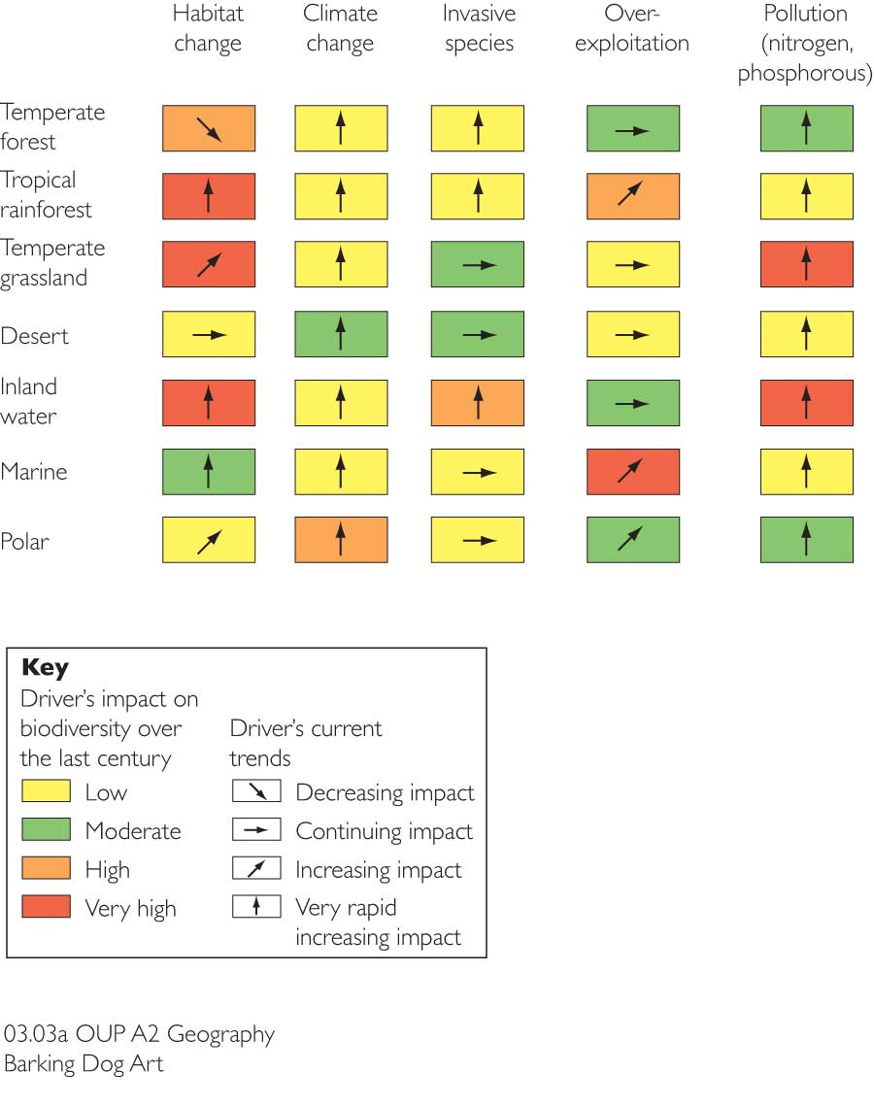
What is the image to the right showing? Explain it:

Threat | Explain why this is a threat
Habitat Change | ……………………………………………………………………………………………………………………………………………………………………  ……………………………………………………………………………………………………………………………………………………………………  ……………………………………………………………………………………………………………………………………………………………………  ……………………………………………………………………………………………………………………………………………………………………  ……………………………………………………………………………………………………………………………………………………………………  ……………………………………………………………………………………………………………………………………………………………………
Over-Exploitation | ……………………………………………………………………………………………………………………………………………………………………  ……………………………………………………………………………………………………………………………………………………………………  ……………………………………………………………………………………………………………………………………………………………………  ……………………………………………………………………………………………………………………………………………………………………  ……………………………………………………………………………………………………………………………………………………………………  ……………………………………………………………………………………………………………………………………………………………………
Invasive Species | ……………………………………………………………………………………………………………………………………………………………………  ……………………………………………………………………………………………………………………………………………………………………  ……………………………………………………………………………………………………………………………………………………………………  ……………………………………………………………………………………………………………………………………………………………………  ……………………………………………………………………………………………………………………………………………………………………  ……………………………………………………………………………………………………………………………………………………………………
Pollution | ……………………………………………………………………………………………………………………………………………………………………  ……………………………………………………………………………………………………………………………………………………………………  ……………………………………………………………………………………………………………………………………………………………………  ……………………………………………………………………………………………………………………………………………………………………  ……………………………………………………………………………………………………………………………………………………………………
Climate Change | ……………………………………………………………………………………………………………………………………………………………………  ……………………………………………………………………………………………………………………………………………………………………  ……………………………………………………………………………………………………………………………………………………………………  ……………………………………………………………………………………………………………………………………………………………………  ……………………………………………………………………………………………………………………………………………………………………  ……………………………………………………………………………………………………………………………………………………………………
In your opinion, which is the biggest named threat to ecosystems & why?

Three named hotspots under threat:
Hotspot | Explain why they are threatened and where they are located
The Caucasus | …………………………………………………………………………………………………………………………………………………………………  …………………………………………………………………………………………………………………………………………………………………  …………………………………………………………………………………………………………………………………………………………………  …………………………………………………………………………………………………………………………………………………………………  …………………………………………………………………………………………………………………………………………………………………  …………………………………………………………………………………………………………………………………………………………………  …………………………………………………………………………………………………………………………………………………………………  …………………………………………………………………………………………………………………………………………………………………  …………………………………………………………………………………………………………………………………………………………………  …………………………………………………………………………………………………………………………………………………………………  …………………………………………………………………………………………………………………………………………………………………  …………………………………………………………………………………………………………………………………………………………………  …………………………………………………………………………………………………………………………………………………………………  …………………………………………………………………………………………………………………………………………………………………
Southwest Australia | …………………………………………………………………………………………………………………………………………………………………  …………………………………………………………………………………………………………………………………………………………………  …………………………………………………………………………………………………………………………………………………………………  …………………………………………………………………………………………………………………………………………………………………  …………………………………………………………………………………………………………………………………………………………………  …………………………………………………………………………………………………………………………………………………………………  …………………………………………………………………………………………………………………………………………………………………  …………………………………………………………………………………………………………………………………………………………………  …………………………………………………………………………………………………………………………………………………………………  …………………………………………………………………………………………………………………………………………………………………  …………………………………………………………………………………………………………………………………………………………………  …………………………………………………………………………………………………………………………………………………………………  …………………………………………………………………………………………………………………………………………………………………  …………………………………………………………………………………………………………………………………………………………………  …………………………………………………………………………………………………………………………………………………………………
Atlantic Forest | …………………………………………………………………………………………………………………………………………………………………  …………………………………………………………………………………………………………………………………………………………………  …………………………………………………………………………………………………………………………………………………………………  …………………………………………………………………………………………………………………………………………………………………  …………………………………………………………………………………………………………………………………………………………………  …………………………………………………………………………………………………………………………………………………………………  …………………………………………………………………………………………………………………………………………………………………  …………………………………………………………………………………………………………………………………………………………………  …………………………………………………………………………………………………………………………………………………………………  …………………………………………………………………………………………………………………………………………………………………  …………………………………………………………………………………………………………………………………………………………………  …………………………………………………………………………………………………………………………………………………………………  …………………………………………………………………………………………………………………………………………………………………  …………………………………………………………………………………………………………………………………………………………………  …………………………………………………………………………………………………………………………………………………………………
