**1.** Tick the correct box to show whether or not each of the following is a process of coastal erosion.

**True** **False**

Saltation  

Hydraulic Power  

Corrosion  

(Total 3 marks)

**2.** The figure belowshows how freeze thaw weathering occurs.  
Add a sentence in each box to explain freeze thaw weathering.

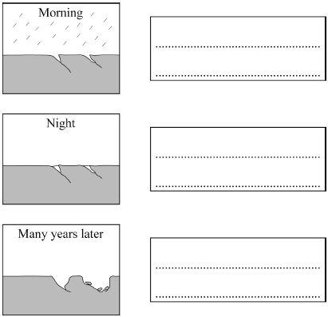

(Total 3 marks)

**3.** For a coastal environment that you have studied, describe the environment and explain why it provides a suitable habitat for the species living there.

...............................................................................................................................................

...............................................................................................................................................

...............................................................................................................................................

...............................................................................................................................................

...............................................................................................................................................

...............................................................................................................................................

...............................................................................................................................................

...............................................................................................................................................

...............................................................................................................................................

...............................................................................................................................................

...............................................................................................................................................

...............................................................................................................................................

(Total 6 marks)

**4.** Chesil Beach has been formed partly as a result of longshore drift. With the help of a diagram, explain how longshore drift works.

|  |
| --- |
|  |

...............................................................................................................................................

...............................................................................................................................................

...............................................................................................................................................

...............................................................................................................................................

...............................................................................................................................................

...............................................................................................................................................

...............................................................................................................................................

...............................................................................................................................................

...............................................................................................................................................

...............................................................................................................................................

...............................................................................................................................................

...............................................................................................................................................

(Total 6 marks)