Christ the Redeemer

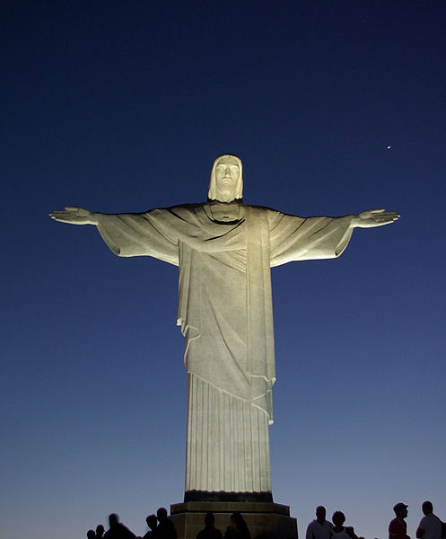

Why would people visit?

* It offers incredible views of the city of Rio
* It is a marvellous example of human creativity
* For many Christian people it is very inspiring to see their lord in such a unique way
* It has become a symbol for Rio de Janeiro and is known all over the world

**Location:** Rio de Janeiro: Brazil

**Built:** Between 1922 and 1931

**Importance:** It is the 5th largest statue of Jesus in the world. It is almost 40 metres tall and is located at the top of the 700 metre high Corcovado Mountain.

**Tourism:** Rio de Janeiro is an extremely popular place for tourists. It receives more than any other South American city with 2.82 million international tourists a year.

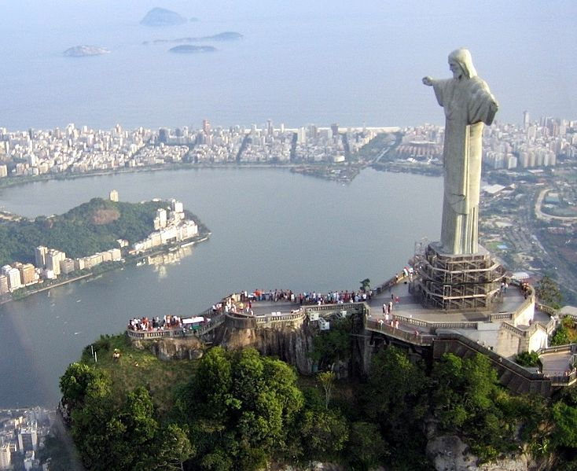

Damages!

* The statue was struck by lightning in February 2008.
* In 2010 a house painter was arrested for spraying graffiti on the statue. The mayor called this a ‘crime against the nation’.

Rio De Janeiro: Tourism



“I visited Rio and had the time of my life! Christ the Redeemer was amazing and the views were spectacular. I was very worried about the crime through as Rio has some very poor people and very high crime rates.”

Rio Carnival

One of the most popular carnivals in the world, the Rio Carnival is fantastic for tourists.

Here you will see some of the best costumes and the best atmosphere you can imagine!

Beaches

Rio de Janeiro has some of the worlds most popular sandy beaches. Every day loads of people flock to the beaches to soak up the warm sun and take a dip.