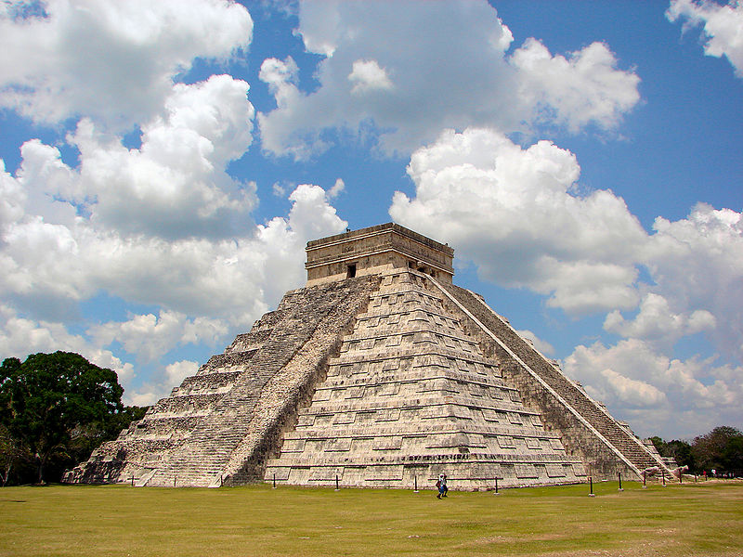Pre- Hispanic City of Chichen Itza

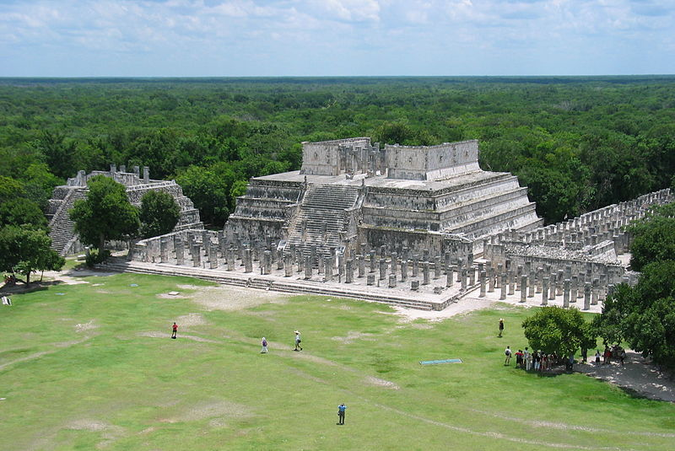

Who Were the Mayan People?

The Mayans were a civilisation who lived in parts of South America before Europeans invaded them.

The Mayans were amazing people and had the only written language in South America at this time.

They also had great religion and art and spent a lot of time looking at the stars and trying to work out the universe.

They lived around 1,400 years ago!

The Temple of the Warriors

This is a large temple with lots of stone columns that are supposed to be warriors.

Chichen Itza has lots of important strctures such as this which give us clues to know how the Mayan People lived and what they were like.

**‘El Castillo’**

**Location**: Yucatan, Mexico

**Built By:** The Mayan Civilisation around the year 600

**Importance:** Chichen Itza was one of the largest Mayan Cities and holds lots of clues about the way they lived.

**Tourism:** The site receives around 1.2 million visitors every year.

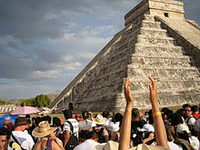

‘The Day of the Spring Equinox’

Several thousand tourists flood to Chichen Itza on this day to view the shadow of a serpant caused by the sun. Many people see this is an important moment.

Many parts of Chichen Itza have strange light effects such as this.

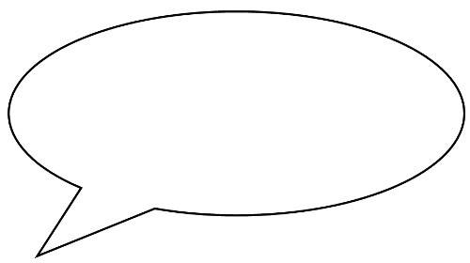Tourism at Chichen Itza



What can people do there?

* Many of the monuments have been closed off to people visiting the site.
* In 2006 an American woman from San Diego died when she fell from El Castillo.
* Visitors can still walk around the monuments but cannot climb them or go inside them.
* With all you now know about the site. How would you advise people to behave there?

Amount of Tourists

“The Mexican Government believes that the amount of tourists that visit Chichen Itza will double this year.

How do you think this will affect peoples enjoyment of the wonder?

We visited Chichen Itza from the popular tourist resort of Cancun in Mexico. It was only a short bus journey. We really loved seeing it but it was a bit busy and noisy with all the people there.