[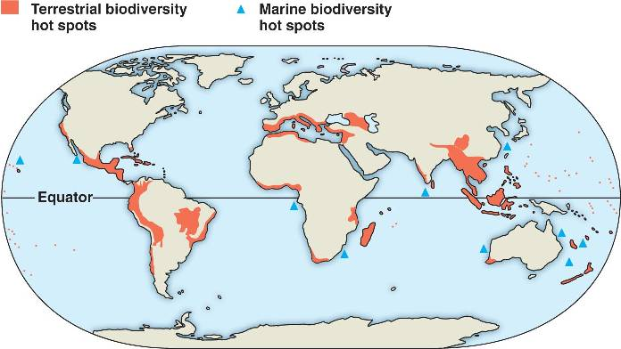](http://www.google.co.uk/url?sa=i&rct=j&q=biodiversity+hotspots&source=images&cd=&cad=rja&docid=J7XWfvp20tzYYM&tbnid=_NwmRRn6iSxLTM:&ved=0CAUQjRw&url=http://bio1152.nicerweb.com/Locked/media/ch56/hotspot.html&ei=KWcnUYXKI-jK0QX0xIDQBA&psig=AFQjCNGdypYqdTMPpCxvR2HBmABFQ6AfBQ&ust=1361623203092263)**Biodiversity hotspots**

Polynesia

Indonesia

Tropical Andes

Madagascar

Mediterranean basin