**Global agriculture**

**Source B- Key terms;**

**Subsistence agriculture**; A means of supporting life by being able to meet one’s own basic needs of food, water and shelter

**Commercial agriculture**; A farming system which produces products for sale,

**Shifting cultivation;** A form of agriculture where a plot is tilled (cultivated) for several years, then left to rest while the farmer clears and tills another plot.

**Green revolution;** The development in the 1960s of HYVs (High-yielding varieties) of the staple cereals, wheat and rice. HYVs yield more than double those of traditional varieties (TVs).

**Agribusiness;** Large scale, capital-intensive farming, sometimes linked to other parts of the food system

**Arable**; Growing and selling crops e.g. wheat

Pastoral; Growing mainly grass which is eaten by animals like cows

**Dairy;** A pastoral farm which mainly keeps cattle

**Mixed;** A farm that does not specialise

Source A- Global headlines

* In all countries agriculture is the largest user of land and the main economic activity of rural areas
* In MEDCs commercial agriculture is dominant whereas in LEDCs subsistence agriculture is dominant
* Global demand for food is predicted to increase by 70% by 2050 – an increase of 3-4% per year.
* Food production must be doubled sustainably in order to feed the world's inhabitants.
* Global population reached 7 billion in October 2011; it is predicted to reach 9 billion by 2050.
* The EU's agricultural productivity increased by less than 1% last year.
* In 2007 and 2008, the EU was a net importer of 35 million hectares of cropland outside its borders to meet its populations’ needs.
* Net imports of virtual agricultural land have increased by about 40% – or almost 10 million ha over the course of a decade.

[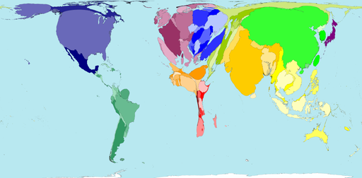](http://www.worldmapper.org/images/largepng/123.png)

Figure 1.2 Global cereals production;

**Territory size shows the proportion of worldwide cereal production that occurs there.**

"For about a third of the world’s population, rice equals life. The cereal provides more than half the daily calories that these people consume." John Travis, 2002

Figure 1.1 shows the percentage of the labour force involved in agriculture in selected countries

|  |  |  |  |
| --- | --- | --- | --- |
| Groups | Population (billion) | % of workers in agriculture | Examples |
| Low-income countries | 3.3 | 67 | Haiti, Mozambique, Nepal |
| Lower- middle-income countries | 1.0 | 34 | Bolivia, Turkey, Morocco |
| Upper- middle- income countries | 0.6 | 20 | Brazil, Greece, Malaysia |
| High-income countries | 0.9 | 5 | Australia, Netherlands, USA |

Source; Prosser et al (2000) *Landmark AS Geography*.

[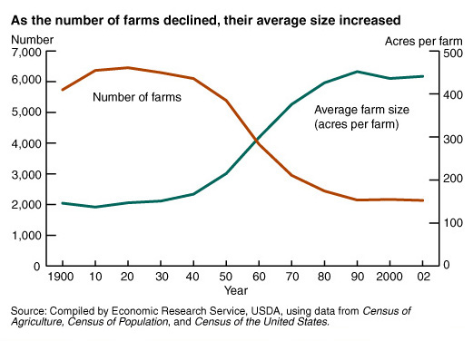](http://www.google.co.uk/url?sa=i&rct=j&q=&esrc=s&frm=1&source=images&cd=&cad=rja&docid=5wQ7fjNCyt8k5M&tbnid=CxYr6lw4n1LilM:&ved=0CAUQjRw&url=http://www.architecturefordevelopment.com/2011/02/the-river-of-urbanisation/&ei=x9a-UcSJKeSk0QWpy4G4CQ&bvm=bv.47883778,d.d2k&psig=AFQjCNGc2lMcG-7trSW-nG87yERwGQAaCg&ust=1371547705742494)

**Questions**

1. Consider sources A and B and figure 1.1; Why is agriculture particularly important for poor countries?
2. Look at figure 1.1
   1. Describe the pattern of workers
   2. Suggest reasons for the pattern you have described in (a)
3. Look at figure 1.2 Describe the global pattern of cereal production (think about the size of the countries in relation to how they look on a conventional map)
4. Using figure 1.3 describe the changes in farm numbers and size between 1920 and 2000.
5. Read Source D Outline why training troops working in Afghanistan is so important

Source D; Afghan farmers return to opium as other markets fail; By David Lyon BBC.

Three times as much opium was produced in Helmand last year as when British troops went there in 2006, and a new [UN forecast says that this year's crop will be even higher](http://www.unodc.org/documents/crop-monitoring/Afghanistan/ORAS_report_2013_phase12.pdf)**.** Opium is the raw material for heroin, and most of the illegal drugs for sale on the UK's streets come from Afghanistan.

Like many other farmers in Helmand province, Hamidullah planted cotton last year, encouraged by British and American agricultural advisers.

But there was no market for it, and he planted opium poppies again this year. "The price of cotton is very low," he said. "It does not cover the cost of production. "He has been forced to sell off his cotton crop at a loss, a bit at a time, to feed his family. But he calculates that opium is ten times as profitable to plant. Of the two large cotton ginning plants in Helmand, one lies idle, with acres of unsold cotton stored in a field next door. Foreign agricultural experts have been trying to persuade Helmand's farmers to plant alternative crops for many years, but most schemes have failed. A report by the UN's Office on Drugs and Crime (UNODC) forecasts an increase in opium production this year and says this has been partly caused by the lack of agricultural assistance. It also blames this "worrying situation" on insecurity. As international troops wind down their combat role, the increase in poppy cultivation is a significant failure for the international project, and particularly the UK's role in it. Most of the worldwide production of illegal heroin, the drug refined from opium, comes from Afghanistan. The UK took a lead role in counter-narcotics from the beginning, and sent troops to Helmand in 2006 partly because this was the largest area of poppy cultivation. The UN report predicts that this year more than 75,000 hectares of land in Helmand is under cultivation for opium poppies, three times as much as in 2006 - and this is expected to increase. The new governor of Helmand, has introduced an extensive programme of eradication. This involves workers going into an area under police protection physically to destroy crops and smash the wells which irrigate the land. The opium produced does not only go out along smugglers' trails through Pakistan and Iran, but also feeds a growing population of addicts in Afghanistan, now believed to be around one-million. The FCO said the UK would continue to support the Afghan government's efforts to tackle opium production, including law enforcement and developing alternative livelihoods for farmers.

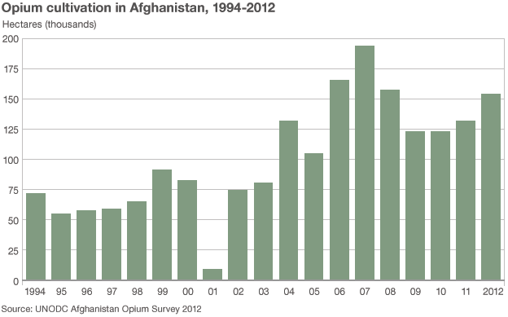

Source C- Physical constraints of agricultural systems;

* Temperature
* Water availability
* Evapotranspiration
* Soils
* Slope and terrain

Human constraints of agricultural systems;

* Systems of land ownership
* Inheritance laws
* Accessibility
* Markets
* Competition
* Government

Figure 1.3 A graph to show average farm size and

number of farms in the USA