Africa: Up for Grabs?
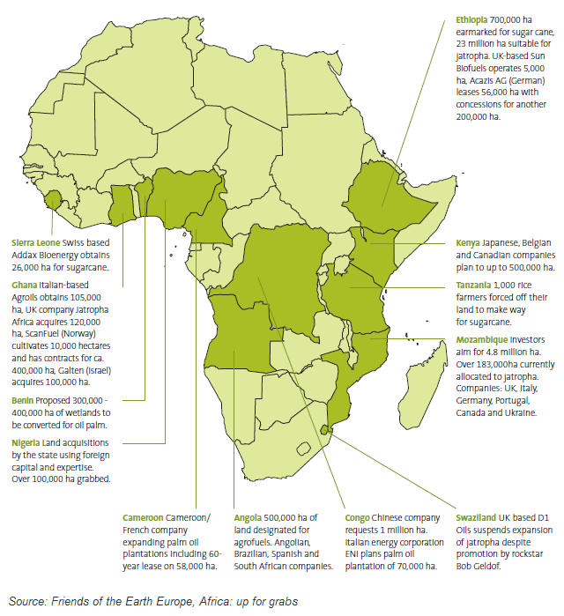
Worldwide, 227 million ha of land has been sold, leased or licensed in large-scale land deals since 2001, mostly by international investors.
Over half of these deals occurred in Africa, this would amount to the size of Germany!
International investment plays a vital role in development and reducing poverty.
Investment e.g. for biofuels, can improve livelihoods and bring jobs, services and infrastructure when managed properly.
BUT this new wave of land deals in Africa is not the investment millions had been waiting for.
Many of the world's poorest people are being left worse off by the frantic competition for land.

Why Africa? An estimated 70 per cent of the demand for farmland is in Africa. Land is cheap and traditional communal ownership makes people more vulnerable. Sometimes this can be done for the cost of a few gifts to traditional chiefs and promises of bringing "development". African countries such as Ethiopia and Uganda are attractive for their arable land and water resources. Investors want to produce food for people overseas, meet biofuels targets and make an easy profit.

Francis Longoli, a small farmer from Kiboga district of central Uganda:
"I remember my land, three acres of coffee, many trees – mangoes and avocados. I had five acres of bananas, 10 beehives, two beautiful permanent houses. My land gave me everything. People used to call me 'omataka' – someone who owns land. Now that is no more. I am one of the poorest now.”
Damaging Effects on Communities
Land grabs are throwing millions of farming families and indigenous peoples off their land. The rights and needs of the people living on the land are often ignored, leaving them homeless and without land to grow enough food to eat and make a living. Benefits of the agriculture remain with the foreign buyers who are mainly interested in exports, leaving poor regions with fewer dependable land resources and further threatening their stability.
Oxfam says companies and governments need to take urgent steps to improve land rights outcomes for people living in poverty. Power relations between investors and local communities need to change if investment is to contribute to rather than undermine the food security and livelihoods of local communities.

Case Studies
In Uganda, at least 22,500 people have lost their homes and land to make way for a British timber company, the New Forests Company. NFC started planting in 2005 and planned to invest over $47 million in ten years and has so far planted about 12 million trees. The New Forests Company stated that the majority of local residents had no legal right to the land and therefore they were to be removed. People were evicted without meaningful consultation or compensation to make way for their plantations. Read the news paper article listed to gain your own information into the case.
http://www.guardian.co.uk/environment/2011/sep/22/uganda-farmer-land-gave-me-everything

Ethiopia is one of the hungriest countries in the world with 2.8 million people needing food aid, but paradoxically the government is offering at least 3 million hectares of its most fertile land to rich countries and some of the world's most wealthy individuals to export food for their own populations.There are four million pastoral farmers in Ethiopia that are likely to be put at risk if the problems of ‘land grabbing’ are not dealt with soon. Read the article listed bellow to gain your own information into the case.
http://www.bbc.co.uk/news/business-11991926

Key Words: Land rights, land grab, investment, agriculture, evicted, poverty, bio fuel, New Forests Company, Ethiopia, Uganda, resources.

Questions. Use the information you have gained from the case study notes and the weblinks, in addition to your own undersanding to answer the questions bellow.
- What is meant by the term ‘land grab’?
- Why is Africa suffering at the hands of ‘land grabbing’?
- Watch the video clip titled ‘Uganda Land Grab Claim by UK Charity’. How do you think investment has impacted on the lives of the people?
- What impact will climate change will have an impact on the occurence of land grabbing in Africa
- Look at the map on the first page of this worksheet. A common investment highlighted is the cultivation of oil palm. Discuss the possitives and negatives of growing such a crop in Africa.
- “It's not just drought. Or famine. Or a bad harvest. A whole host of interlinked factors are stopping Akiru – and nearly 1 billion people worldwide – from having enough to eat. The global food system is bust. It's time to fix it.” Oxfam, 2011. How does renting land in Africa result in food shortages?

Watch:
‘The Rust for Africa’s Land’ on the New York Times website: http://video.nytimes.com/video/2010/12/22/world/africa/1248069453507/the-rush-for-africa-s-land.html
News World: African Land Grab
http://www.youtube.com/watch?v=q8TjDAevDoo
Uganda Land Grab Claim by UK Charity
http://www.youtube.com/watch?v=_ZyMlRr5X4Q

Explanation
Q1 What is meant by the term ‘land grab’?
This is a low order question that builds on comprehension skills of the pupil. It is based on their ability to interpret sources provided, drawing on required information to answer the question.
Q2 Why is Africa suffering at the hands of ‘land grabbing’?
This is a low order question which is designed to question the pupil’s knowledge and recall from the news article.
Q3 Watch the video clip titled ‘Uganda Land Grab Claim by UK Charity’. How do you think investment has impacted on the lives of the people?
Students are required to comprehend and apply information provided in the context of African people.
Q4 What impact will climate change will have an impact on the occurence of land grabbing in Africa?
This question requires application skills to draw on existing knowledge students have about the effects of climate change gloablly. They have to be aware of challenges in relation to water scarcity and biofuel production to balance their arguement. They are required to ‘apply’ information they are provided with in the text explaining why land grabbing in addition to being aware of wider global issues.
Q5 Look at the map on the first page of this worksheet. A common investment highlighted is the cultivation of oil palm. Discuss the possitives and negatives of growing such a crop in Africa.
This question builds on the student’s ability to synthesise information. It requires information to be drawn from the text and link it with their existing knowledge about oil palm and additional research. This is of a much higher cognitive level than previous questions.
Q6 “It's not just drought. Or famine. Or a bad harvest. A whole host of interlinked factors are stopping Akiru – and nearly 1 billion people worldwide – from having enough to eat. The global food system is bust. It's time to fix it.” Oxfam, 2011. How does renting land in Africa result in food shortages?
Pupils are required to analyse the effects of land grabbing on food shortages.
Q7 Critique the response of the New Forest Company in regards to the questions of their practice in Uganda that have been raised. You will need to use the links provided to gain more information.
This is a high end question, requring children to develop evaluation skills and to form their own opinions. They are required to use geographical knowledge to do so. They will need to be able to produce a both a valdi and balanced arguement for the case of both the people of Uganda and of the NFC. Information will need to be analysed and synthesised before the evaluation can be constructed.

A late note...
I chose this news topic as I have always been very interested in sustainability and development, especailly within African and LEDCs. The Oxfam ‘Grow’ movmeent is fascinating. You can read more at http://www.oxfam.org.uk/get_involved/system/. It was a BBC News article available: http://www.bbc.co.uk/news/world-africa-13688683 which influenced my decision to concentrate on this topic. I believe that students should develop an understanding that not all investment is beneficial and this topic allows students to construct geographical knowledge with a wealth of case studies.

