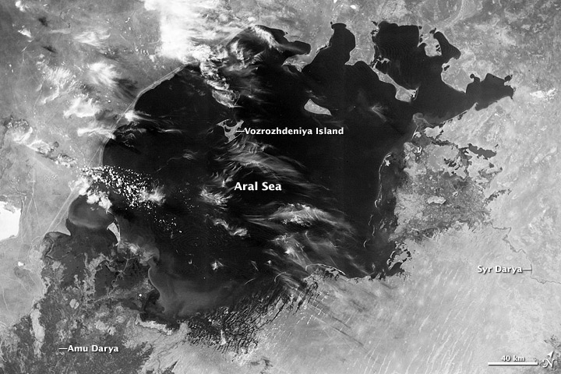
1964 – The Fourth Largest Lake in the World
The Aral Sea is actually not a sea at all. It is an immense lake, a body of fresh water, although that particular description of its contents might now be more a figure of speech than practical fact. In the last 30 years, more than 60 percent of the lake has disappeared. The sequence of images above, acquired by Landsat satellites, shows the dramatic changes to the Aral Sea between 1973 and 2000.
Beginning in the 1960s, farmers and state offices in Uzbekistan, Kazakhstan, and Central Asian states opened significant diversions from the rivers that supply water to the lake, thus siphoning off millions of gallons to irrigate cotton fields and rice paddies. As recently as 1965, the Aral Sea received about 50 cubic kilometers of fresh water per year—a number that fell to zero by the early 1980s. Consequently, concentrations of salts and minerals began to rise in the shrinking body of water. That change in chemistry has led to staggering alterations in the lake's ecology, causing precipitous drops in the Aral Sea’s fish population.
The Aral Sea supported a thriving commercial fishing industry employing roughly 60,000 people in the early 1960s. By 1977, the fish harvest was reduced by 75 percent, and by the early 1980s the commercial fishing industry had been eliminated. The shrinking Aral Sea has also had a noticeable affect on the region's climate. The growing season there is now shorter, causing many farmers to switch from cotton to rice, which demands even more diverted water.
A secondary effect of the reduction in the Aral Sea’s overall size is the rapid exposure of the lake bed. Strong winds that blow across this part of Asia routinely pick up and deposit tens of thousands of tons of now exposed soil every year. This process has not only contributed to significant reduction in breathable air quality for nearby residents, but has also appreciably affected crop yields due to those heavily salt-laden particles falling on arable land.
Environmental experts agree that the current situation cannot be sustained. Yet, driven by poverty and their dependence upon exports, officials in the region have failed to take any preventive action and the Aral continues to shrink.
Although irrigation made the desert bloom, it devastated the Aral Sea. As the lake dried up, fisheries and the communities that depended on them collapsed. The increasingly salty water became polluted with fertilizer and pesticides. Blowing, salty dust from the exposed lakebed became a public health hazard and degraded the soil. Croplands had to be flushed with larger and larger volumes of river water. The loss of the moderating influence of the Aral Sea made winters colder and summers hotter and drier.
Fifty years after its water sources were diverted, the Aral Sea is virtually gone. Some estimates suggest that the lake is just 10 percent of its original size.

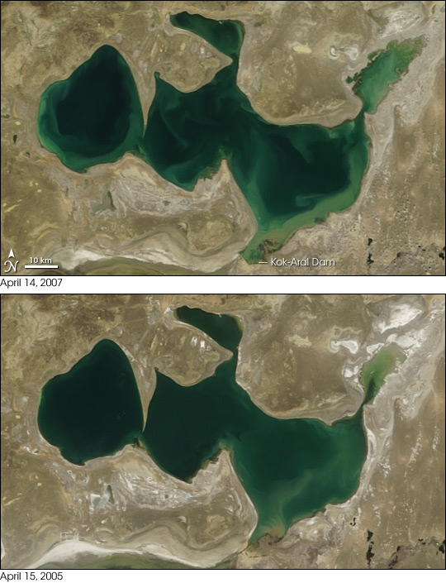
2007 Report on the progress of the Kok-Aral Dam
In 2000, the Aral Sea was in grave condition. This inland sea, which was once Earth’s fourth-largest lake, had been steadily shrinking since the 1960s, when Soviet-era irrigation projects diverted the main rivers sustaining the sea. The lake shrunk to a quarter of its original size in a few decades, creating an environmental and public health disaster. As the lake dried up, winters became colder and harsher, and summers became hotter and more arid. Blowing dust, laden with pesticides and other chemicals, is routinely scoured from the dry lake bed and poses a severe public health hazard.
In 2007, however, the North Aral Sea was enjoying a renaissance, due the construction of a dam in 2005 that prevents water from flowing into the South Aral Sea. This pair of images acquired by the Moderate Resolution Imaging Spectroradiometer (MODIS) on NASA’s Terra satellite shows the recovery of the Aral Sea between April 15, 2005 (bottom), and April 14, 2007 (top). The recovery is most dramatic in the upper right part of the image, although a close look at the lake’s borders show a general rise in water level throughout the lake. Much of this recovery actually occurred in the first year after the dam was completed.
The North Aral Sea owes its rebirth to the Kok-Aral Dam, an $85.8 million project bolstered by a loan from the World Bank. The dam separates the North Aral Sea from its saltier and more polluted southern half. In early 2006, the Embassy of the Republic of Kazakhstan announced that the Aral Sea had shown dramatic recovery in just months, rather than the five to ten years originally predicted.
Local economies, long dependent on the water, were making a comeback as well. One example was Aralsk, the one-time port city that had gradually been surrounded by desert. By the spring of 2006, Aralsk was once again close to the water. On April 9, 2007, BBC News reported that the government of Kazakhstan had secured a new loan of $126 million from the World Bank to build a second dam, aimed at returning water to Heralsk, a former port that was deserted as the lake shrank.

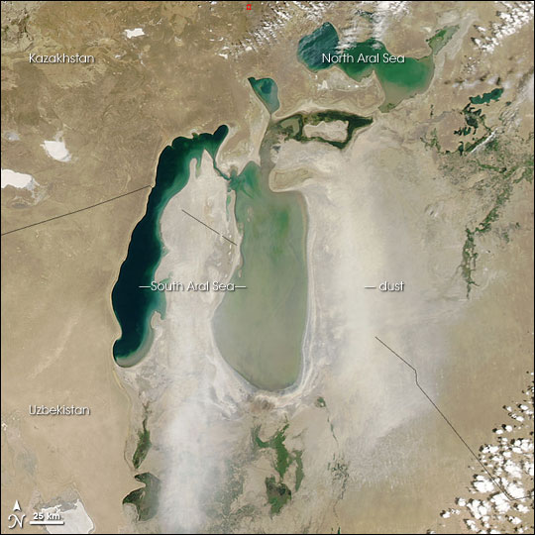
Dust Storms 2006
Straddling the border between Kazakhstan in the north and Uzbekistan in the south, the Aral Sea was once the fourth-largest lake in the world. Soviet-era irrigation diverted water, shrinking the sea to less than half of its 1960 extent. In 2006, a dam built to restore the northern portion of the sea caused a surprisingly rapid recovery. Despite this partial recovery, however, the lake remained surrounded by its dried-up lakebed, and this dry lakebed was the likely source of a dust storm over the Aral Sea on June 13, 2006. The Moderate Resolution Imaging Spectroradiometer (MODIS) flying onboard NASA’s Aqua satellite took a picture of the dust as it blew over the eastern half of the Aral Sea. In this picture, the dust is very light in color, which is characteristic of lakebed sediments.

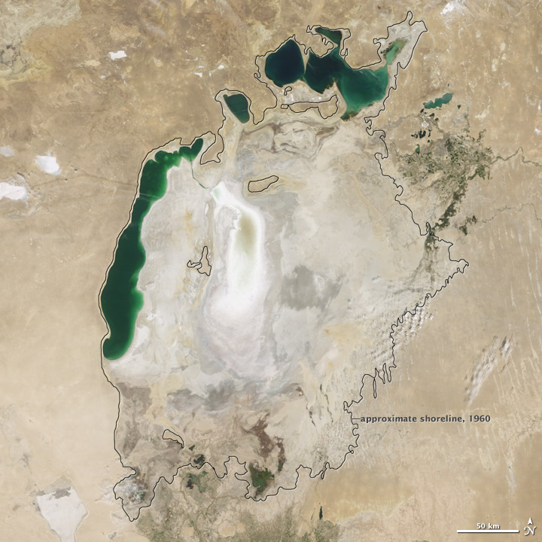
2009- The Southern Aral Sea sacrificed to save the North
Throughout the first half of the twentieth century, the Aral Sea was the world’s fourth-largest lake. In the 1960s, the Soviet Union began a massive irrigation project in what are now Kazakhstan, Uzbekistan, and Turkmenistan, diverting water from the rivers that feed the Aral Sea to irrigate farmland. As its water levels dropped, the lake began splitting into smaller pieces: the Northern (Small) Aral Sea and the Southern (Large) Aral Sea. The Southern Aral Sea further split into eastern and western lobes. The Earth Observatory’s World of Change: Evaporation of the Aral Sea feature tracks this process over the past decade.
This update shows that by August 2009, virtually nothing remained of the Southern Aral Sea’s eastern lobe. The Moderate Resolution Imaging Spectroradiometer (MODIS) on NASA’s Terra satellite captured this true-color image of the Aral Sea on August 16, 2009. Although the Northern Aral Sea (upper right) still appears healthy, the Southern Aral Sea consists of two isolated water bodies: an irregular oval shape directly southwest of the Northern Aral Sea, and the long, thin remainder of the Southern Aral Sea’s far western lobe. Although the faintest glimmers of blue-green appear in the eastern lobe, earth tones predominate, surrounded by a ghostly film of pale beige. Lake sediments from this depleted water body have provided ample material for frequent dust storms.
Much of what finally doomed the Southern Aral Sea was an attempt to save its neighbor to the north. In 2005, Kazakhstan built the Kok-Aral Dam between the lake’s northern and southern portions to preserve water levels in the north. The Northern Aral Sea actually exceeded expectations with the speed of its recovery, but the dam ended prospects for a recovery of the Southern Aral Sea, which some authorities already regarded as beyond help.

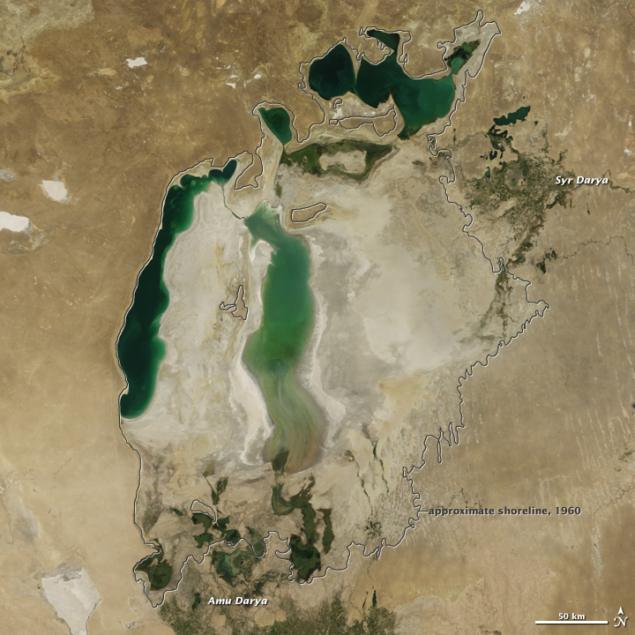

2010 reports that the Aral Sea is naturally recovering
The size of the Aral Sea has long hinged on the Amu Darya, which flows from the high Pamir Mountains in central Asia, across the desert, and into the southern sea. While two rivers empty into the lake—the Amu Darya and the Syr Darya—the Amu Darya is the largest and most fickle source of water. At times in ancient history, the river has bent its course to empty into the Caspian Sea, and the abandoned Aral Sea shrank. The Aral Sea has been at its largest when the Amu Darya feeds it.
Modern trends are no exception: when water began to be diverted from the Amu Darya for vast agricultural projects starting in 1960, the Aral Sea began to shrink. This image, taken on August 26, 2010, by the Moderate Resolution Imaging Spectroradiometer (MODIS) on NASA’s Terra satellite, demonstrates the close connection between the Aral Sea and the Amu Darya River. It is the most recent image in a ten-year sequence published on the Earth Observatory’s World of Change: Shrinking Aral Sea.
Between 2000 and 2009, the Aral Sea steadily shrank. In 2006, severe drought settled in over Amu Darya Basin. Very little water reached the Aral Sea in 2007, and nothing flowed from the Amu Darya to the Aral Sea in 2008 and 2009, says Philip Micklin, a geographer from Western Michigan University who has been monitoring the Aral Sea for many years. Without water from the Amu Darya, the southern Aral Sea rapidly dwindled, the eastern lobe all but disappearing in 2009.
In 2010, however, the drought broke. Snow in the Pamir Mountains was normal, and enough water flowed into the Amu Darya that the river reached the Aral Sea. The muddy pulse of water settled in a shallow layer over the bed of the eastern lobe of the South Aral Sea, making it look much larger than it had in 2009.
Before 1960, the Aral Sea was the fourth largest lake in the world. However, much of the Amu Darya and Syr Darya have been diverted for agriculture, limiting the flow of water into the sea. Since 1960, the Aral Sea has lost 88 percent of its surface area and 92 percent of its water volume, says Micklin

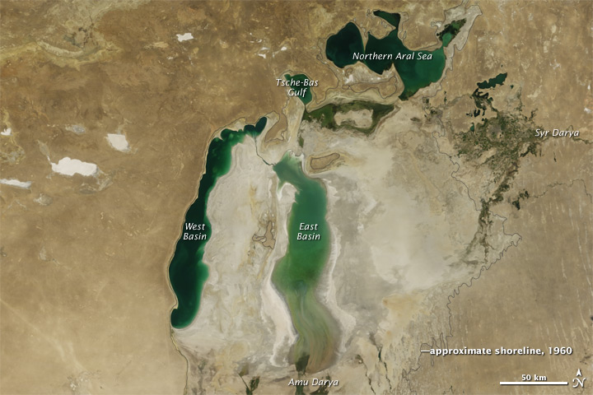
2011 – The South Aral Sea shows signs of recovery
Jewel-like green against the desert of central Asia, the Aral Sea has a long history of change. Over thousands of years, the lake has filled and dried, its fate linked to the flow of the rivers that feed it, particularly the Amu Darya. Since 1960, local rivers have been diverted in large-scale agricultural projects, and the Aral Sea has lost 90 percent of its volume.
Once the world’s fourth largest lake, the rapidly shrinking Aral Sea has fragmented into four bodies of water: the Northern Aral Sea, the eastern and western basins of the Southern Aral Sea, and Tsche-Bas Gulf. Of these, the eastern basin of the Southern Aral Sea and Tsche-Bas Gulf show the most dramatic change in 2011.
Even if efforts were made to restore the Southern Aral Sea, it is unlikely that the it could recover in the near term. More than 50 percent of the flow of the Amu Darya would have to enter the southern Aral Sea to bring it back to life. This water, however, is needed to grow crops to feed the populations of Uzbekistan, Turkmenistan, Kazakhstan, Afghanistan, and Tajikistan. While improvements in irrigation efficiency could restore some water to the sea, it would not be enough for a full recovery.
The Aral Sea is equally unlikely to dry up entirely, argues Philip Micklin, a geographer who has been studying the Aral Sea for decades. The sea still gets water from rain and snowmelt, irrigation runoff, and ground water. As demonstrated from 2010 to 2011, year-to-year fluctuations in rain and snow will likely have a big influence on the sea’s extent, particularly in the shallow eastern basin.

