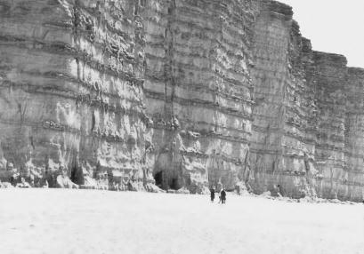 | Graded Bedding | A sedimentary structure that forms when sediments dry and contract. The cracks that form are later in filled with sediment and form casts on the overlying bed.
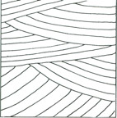 | Bedding | A sediment deposit characterised by coarse sediments at its base, which grade upward into progressively finer ones. Generally represent depositional environments which decrease in transport energy as time passes.
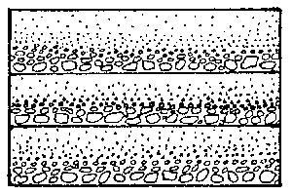 | Ripple marks | Layers of geologic strata in which deposits were laid down at an angle with respect to those above and below, commonly seen in sandstone deposited as dunes.
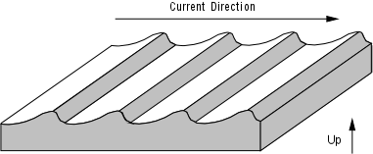 | Desiccation Cracks | A series of small ridges that indicate agitation by water or wind. They can be used to decipher the direction of wind or water flow.
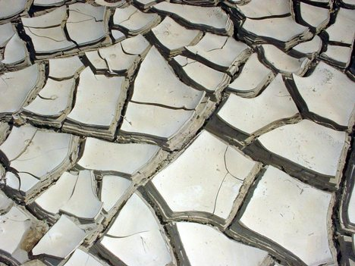 | Cross Bedding | A series of distinct layers of sedimentary rock known as strata.
- Write the title Sedimentary Structures in your books.
- Cut and stick the above sedimentary structure pictures with their correct name and definition.

