**Human activities causing Climate Change**

**Handout**

**Below is a selection of questions for you to answer about the ‘Human activities causing Climate Change’ PowerPoint**

1. **Name the 4 main human activities that relate to climate change.**
2. **Use the diagram to explain the process of Fossil fuels.**

**1.**

**2.**

**3.**

**4.**

**5**

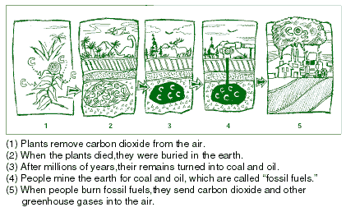

1. **Using the picture of logging below, fill in the gaps to explain deforestation;**

Mature forests store enormous quantities of , which is released in to the when they are cut down.

Forest covers % of the world’s land area. We are destroying square miles a year.

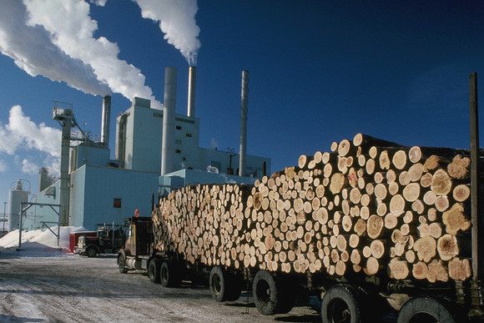

is one of the main causes of habitat loss and extinction of many animals on the planet. By cutting down trees, we are not only contributing to a rapid increase in but we are ruining the survival chance for species all over the world.

1. **Describe the difference between weather and climate by joining the correct explanations;**

**This describes the total of all weather occurring over a period of years in a given place**

**Climate**

**This describes the total of all weather occurring over a period of years in a given place**

**Weather**

**This tells us what it's usually like in the place where you live at a certain time of year.**

1. **Name the 3 mineral fuels that contribute to fossil fuels**

**C:\Users\Jodie\AppData\Local\Microsoft\Windows\Temporary Internet Files\Content.IE5\J2B5P19Y\MC900013354[1].wmf**

**C:\Users\Jodie\AppData\Local\Microsoft\Windows\Temporary Internet Files\Content.IE5\YFZD2WB8\MC900353230[1].wmf**



1. **One example of ‘poor land use’ is uncontrolled urban areas. Can you briefly give an explanation of what this is below;**

**………………………………………………………………………………………………………………………………………………………………………………………………………………………………………………………………………………………………………………**

1. **Give three examples of how composting benefits the prevention of climate change;**

1)

**C:\Users\Jodie\AppData\Local\Microsoft\Windows\Temporary Internet Files\Content.IE5\WAM6DGFT\MC900014530[1].wmf**

2)

3)

**.**

1. 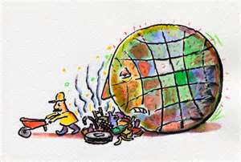**What 2 gases are released as a result of poor waste disposal;**
2. **Name 2 ‘cooling units’ that you use in everyday life and explain how they are a major source of ozone layer depletion?**

**………………………………………………………………………………………………………………………………………………………………………………………………………………………………………………………………**

**………………………………………………………………………………………………………………………………………………………………………………………………………………………………………………………………**

1. **In pairs, write a list detailing what daily and community activities can be done to help prevent climate change? Write below;**

**C:\Users\Jodie\AppData\Local\Microsoft\Windows\Temporary Internet Files\Content.IE5\WAM6DGFT\MC900197730[1].wmf**

**An example of this would be riding a bike to work.**



**Reduce, Reuse & Recycle**